**Hall**

**Management**

**System**

# Test Suite Results

**Preparedby:**

1. ***Subham Ghosh***

**Roll No.:*11CS10060***

**and**

1. ***Sourav Sarkar***

**Roll No.:*11CS30037***

**Problem No.:*19***

**Unit Testing Results (White Box):-**

* Add Emloyee

Before:-

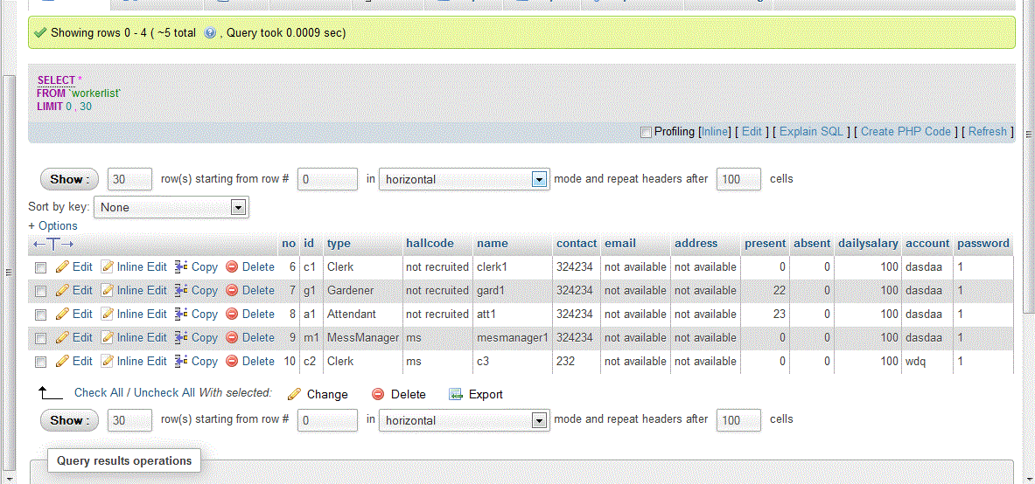

After:-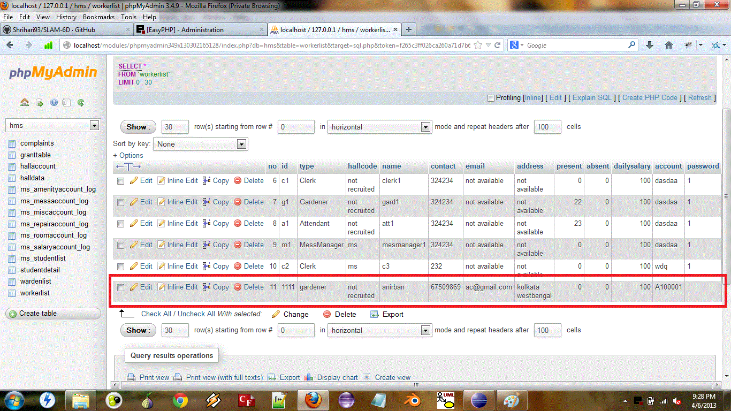

* Add Hall

Before:-

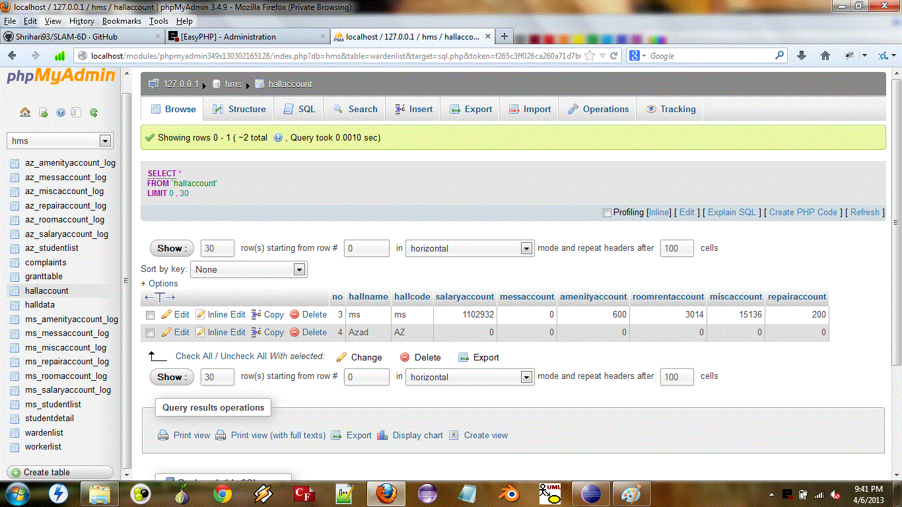

After:-

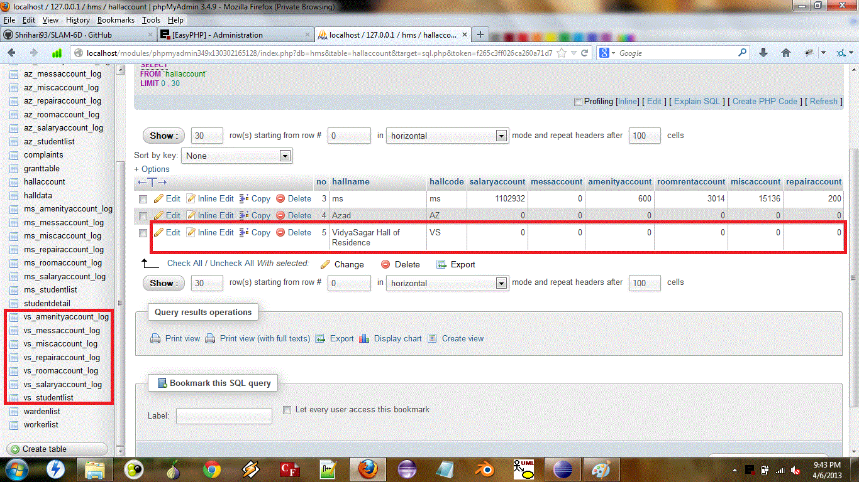

* Add Student

Before:-

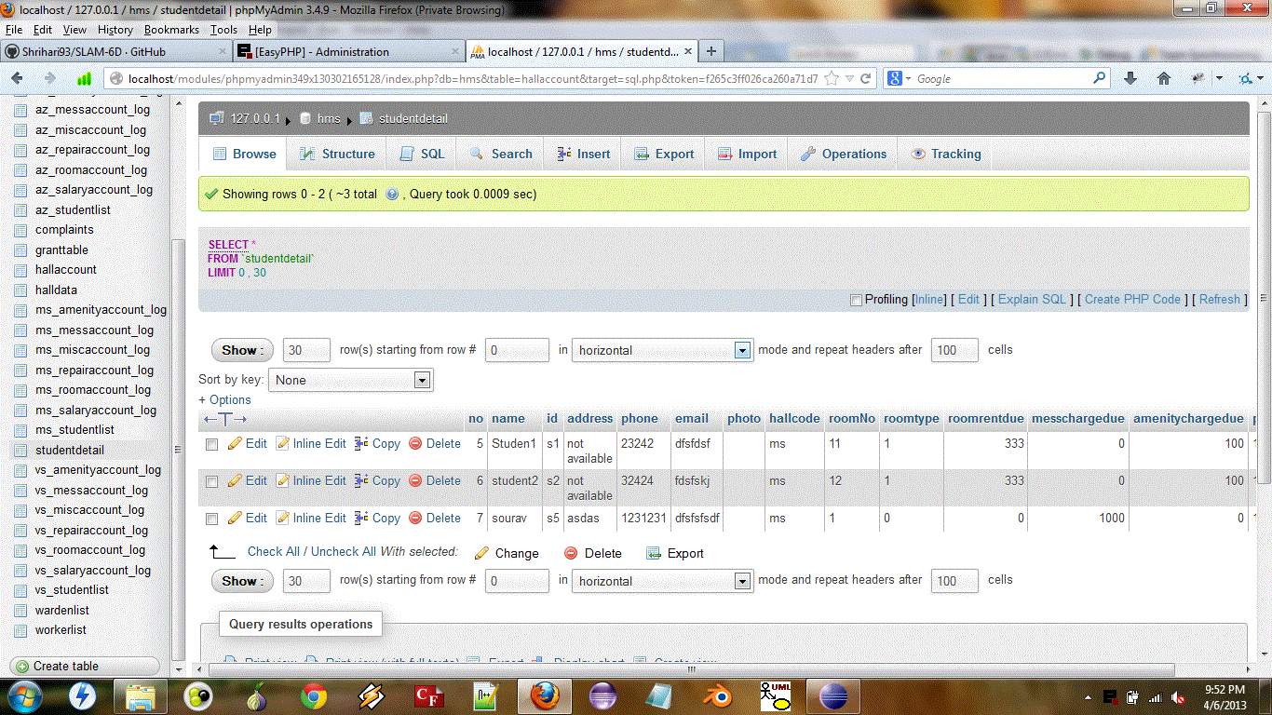

After:-

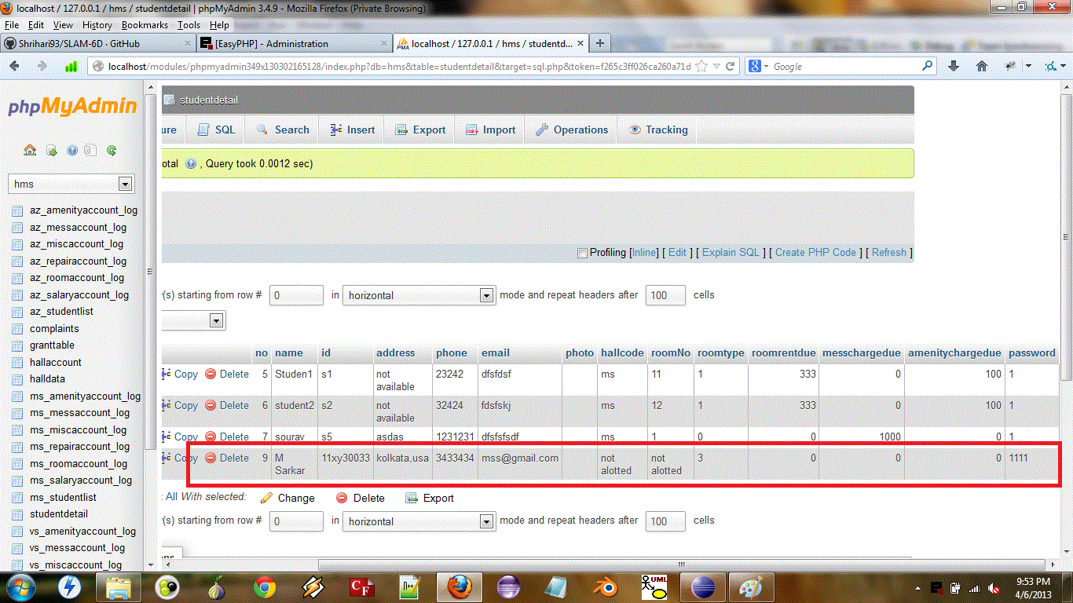

* Add Warden

Before:-

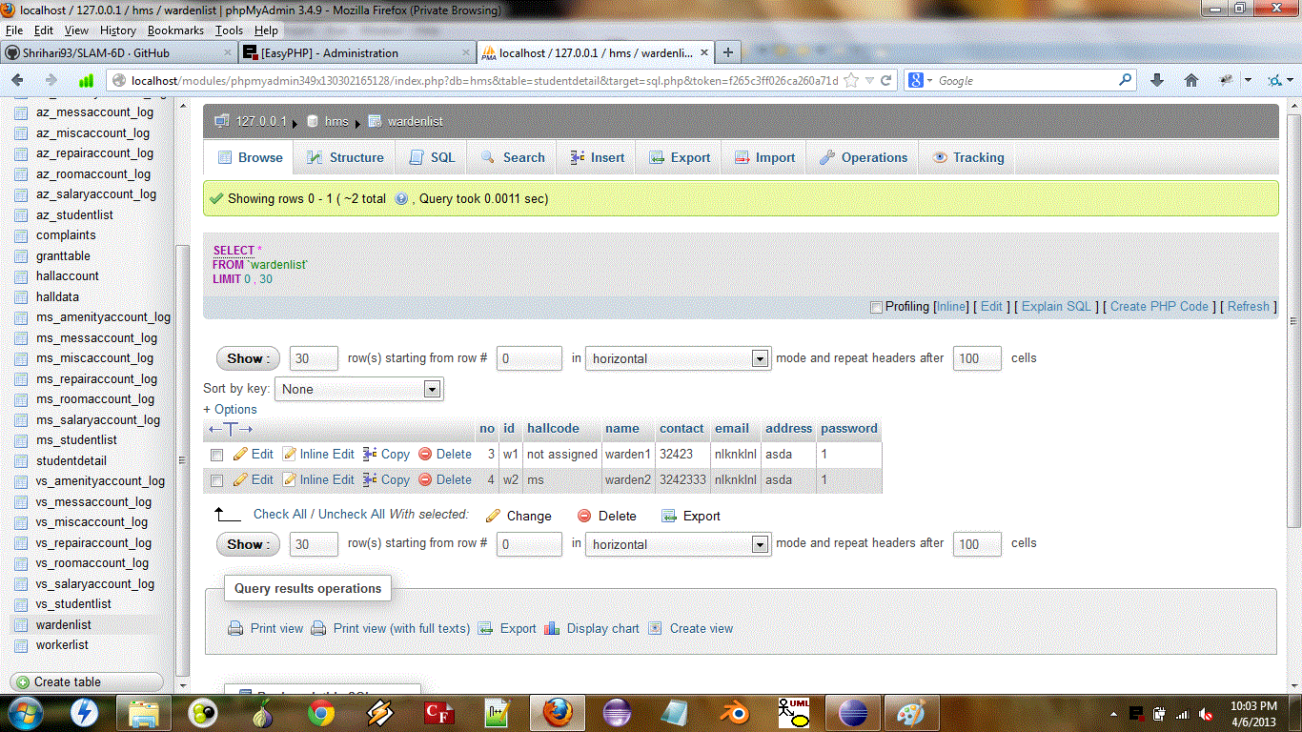

After:-

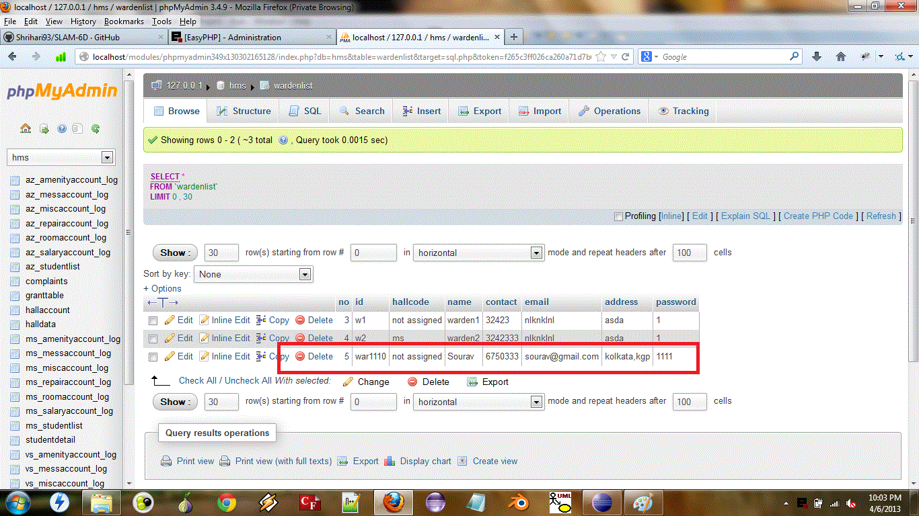

* Change Student Detail

Before:-

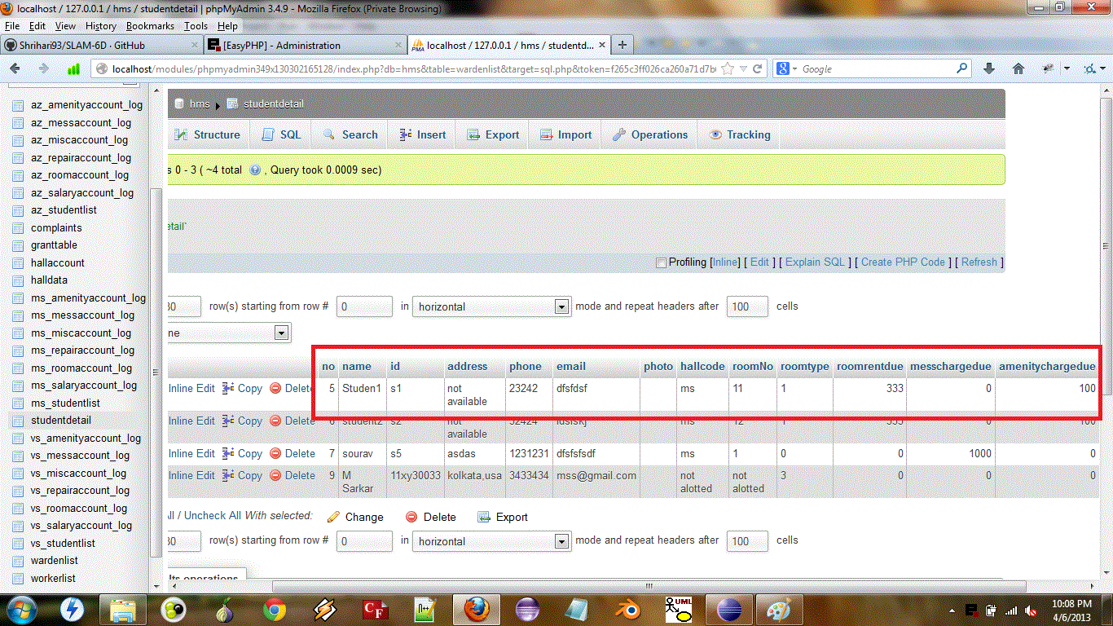

After:-

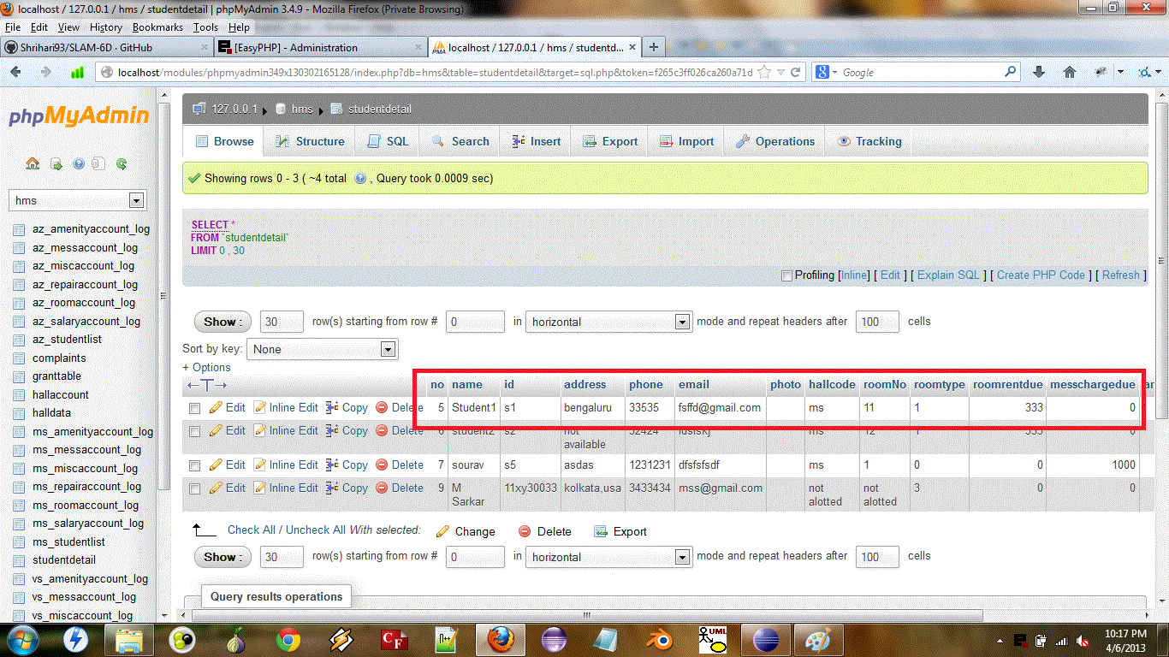

* Change Worker Details

Before:-

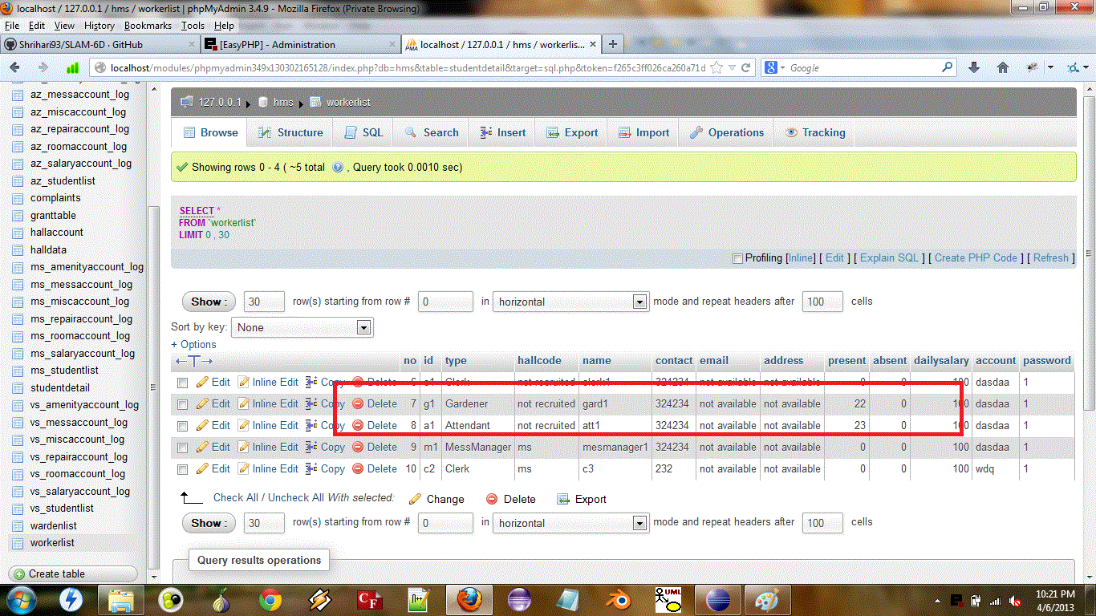

After:-

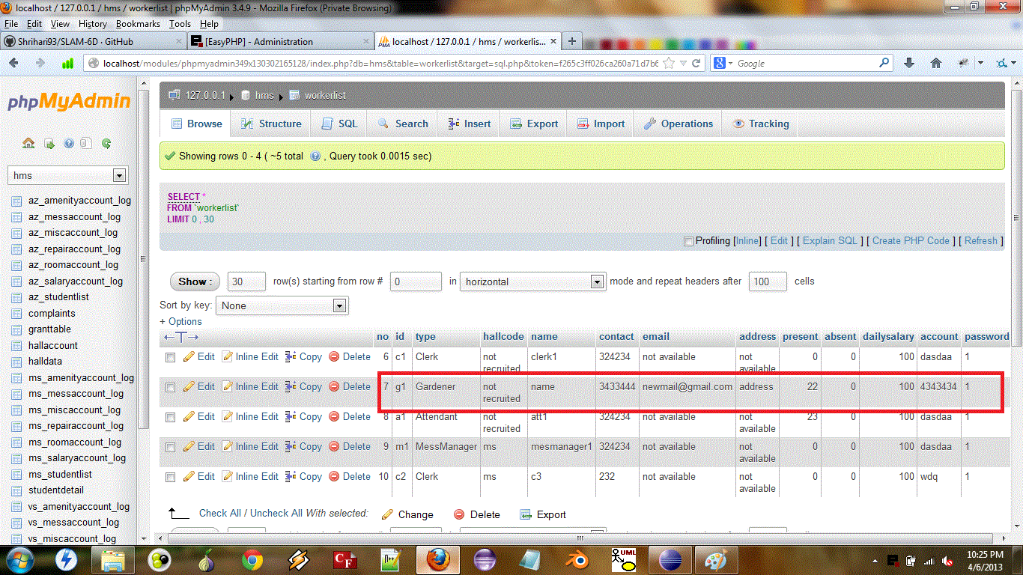

* Enter Amenity Charge

Before:-

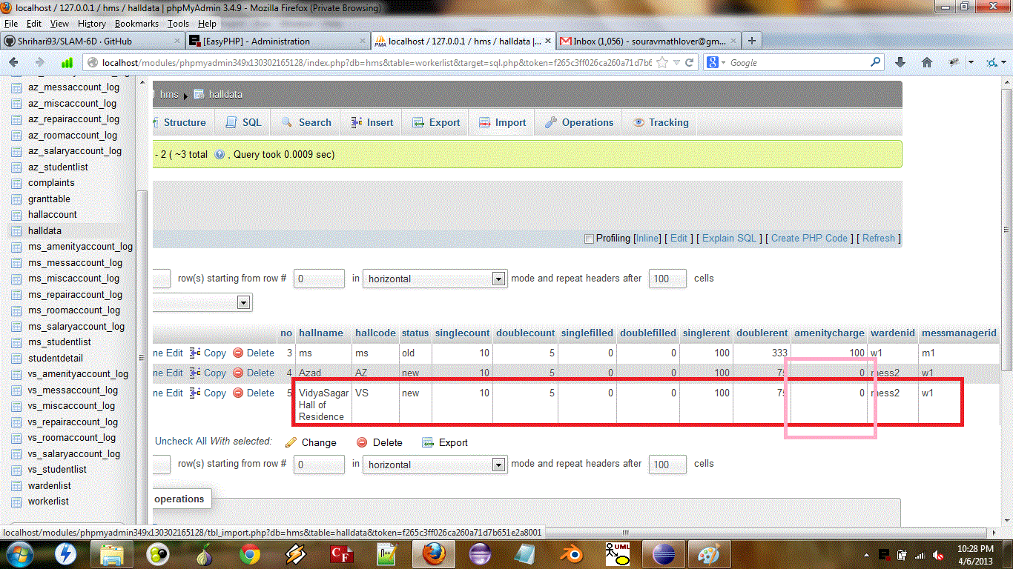

After:-

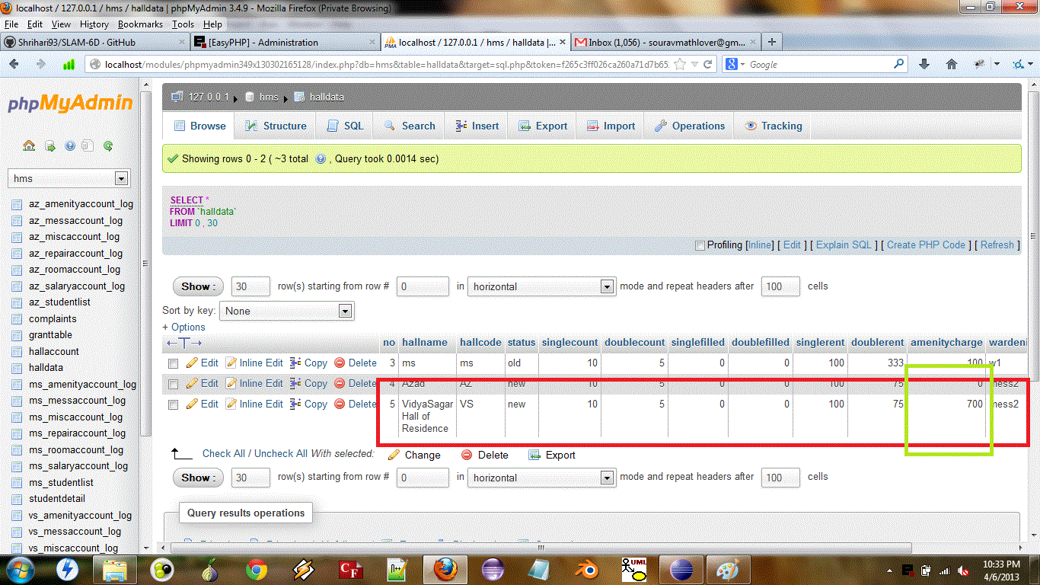

* Fire Worker

Before:-

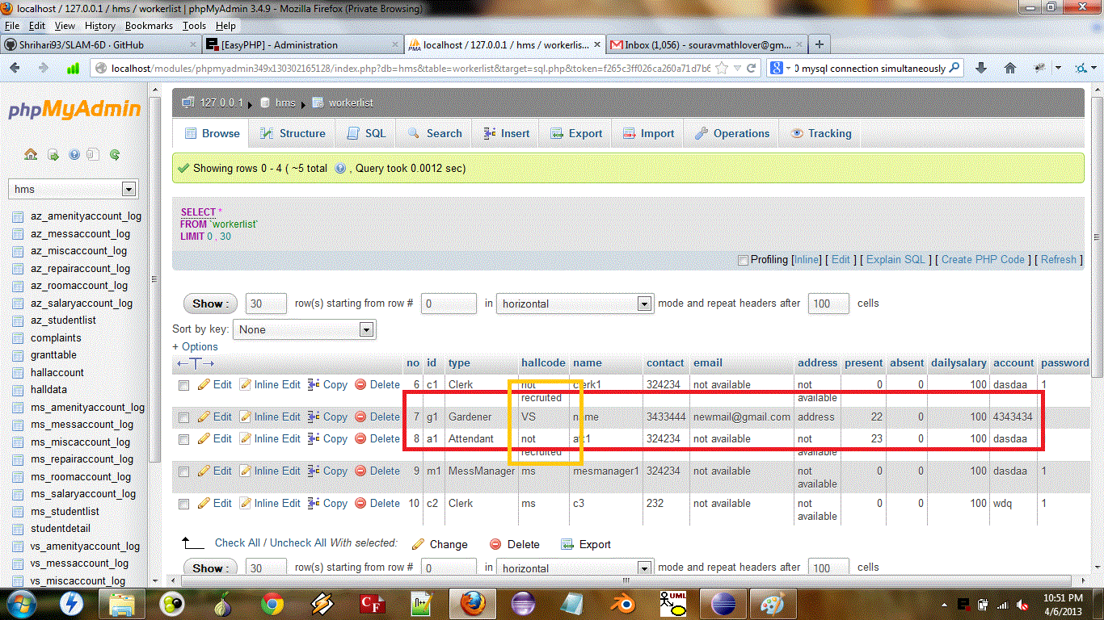

After:-

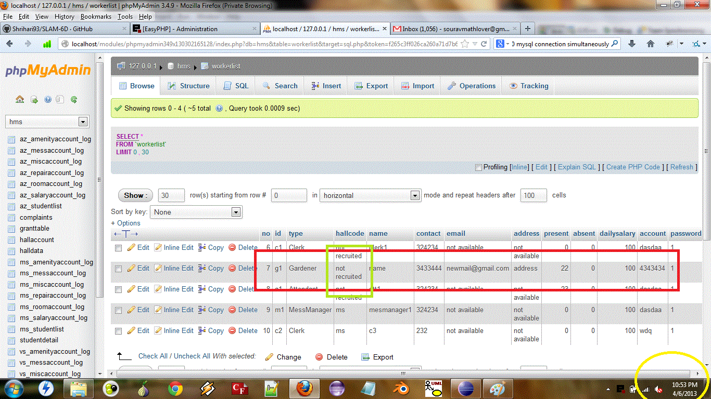

* Generate Cheque

Before:-

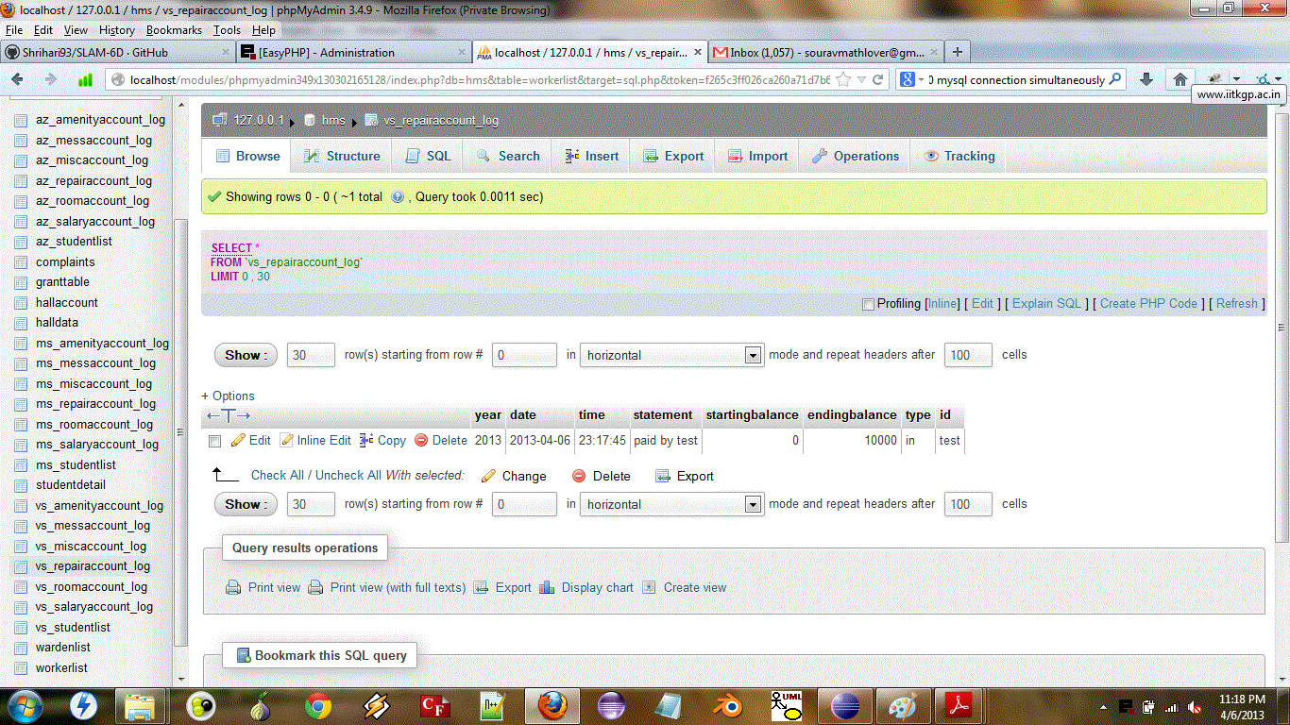

After:-

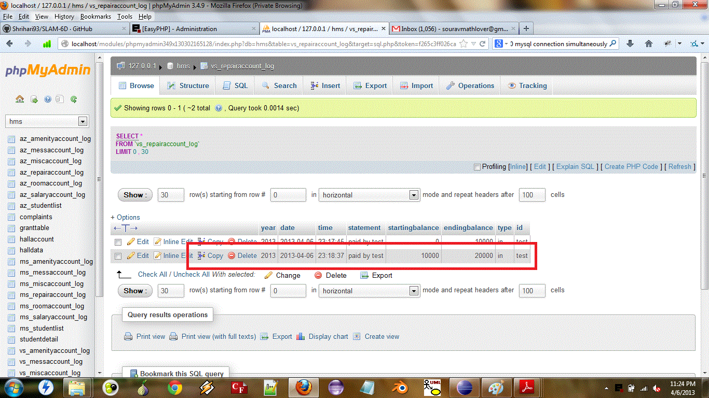

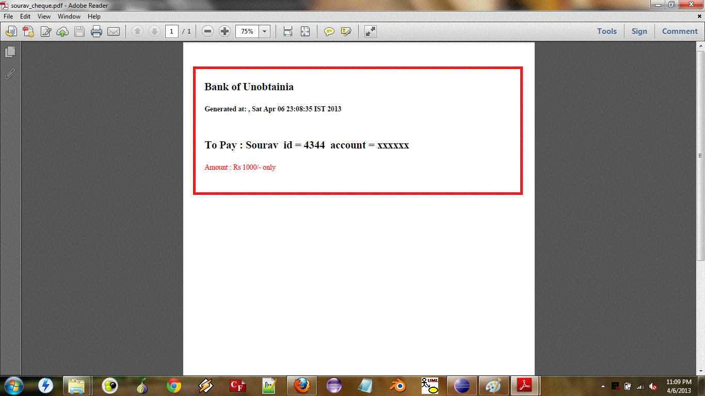

* View Complaints

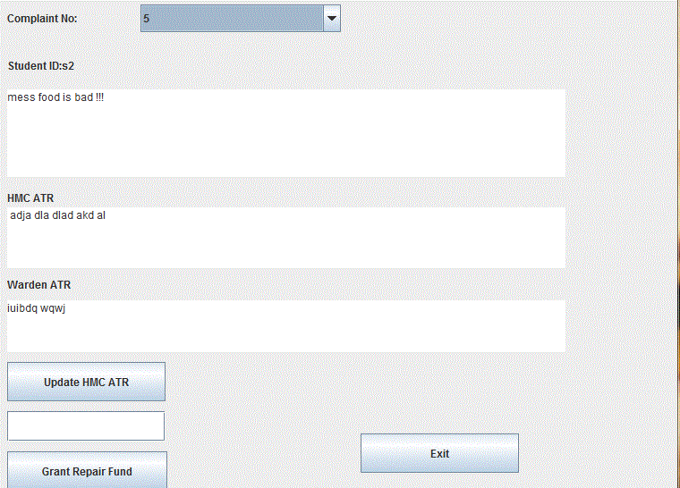

* Salary Payment

Before:-



After:-



* Get Account Statement

Before:-

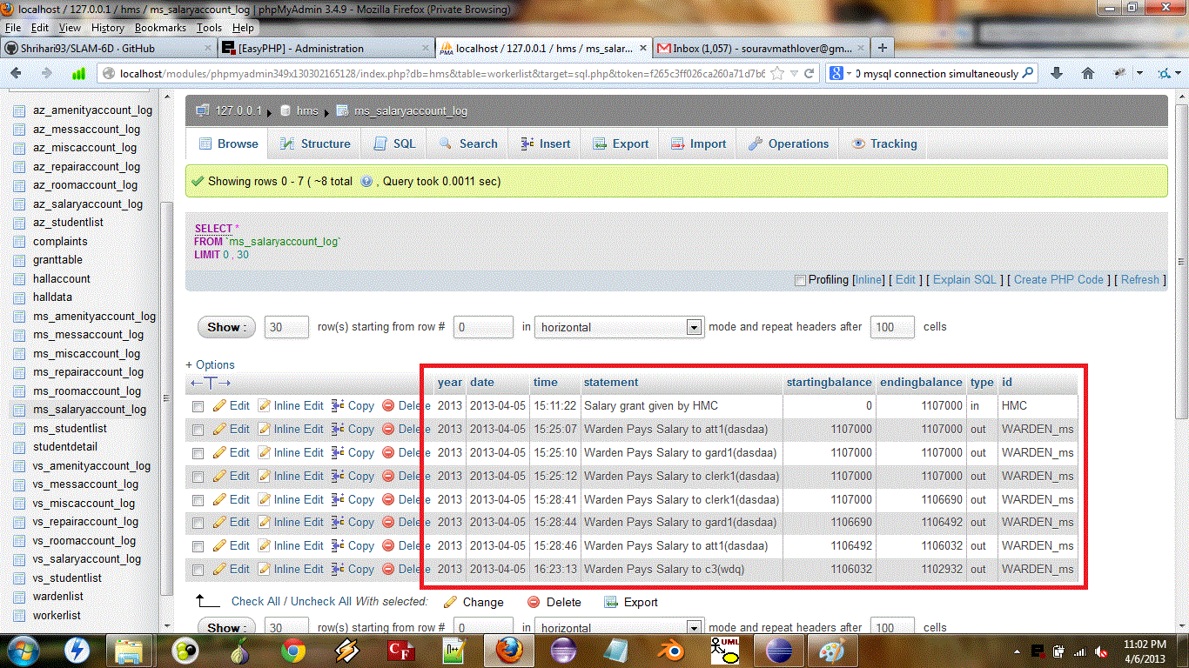

After:-

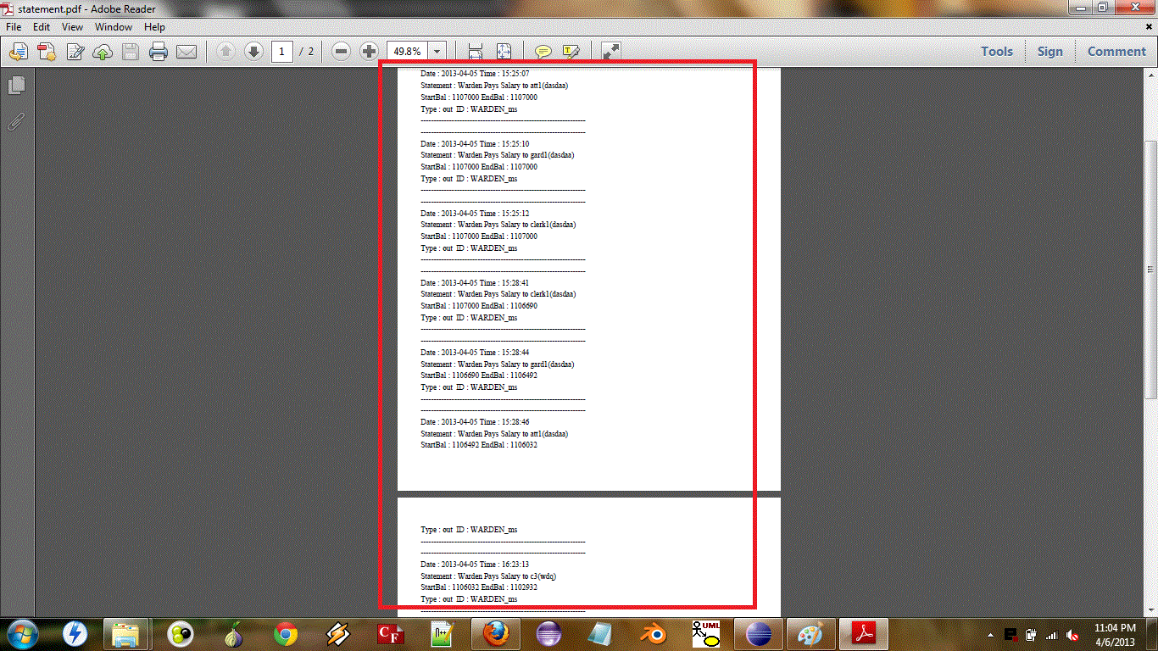

* Recruit Worker

Before:-

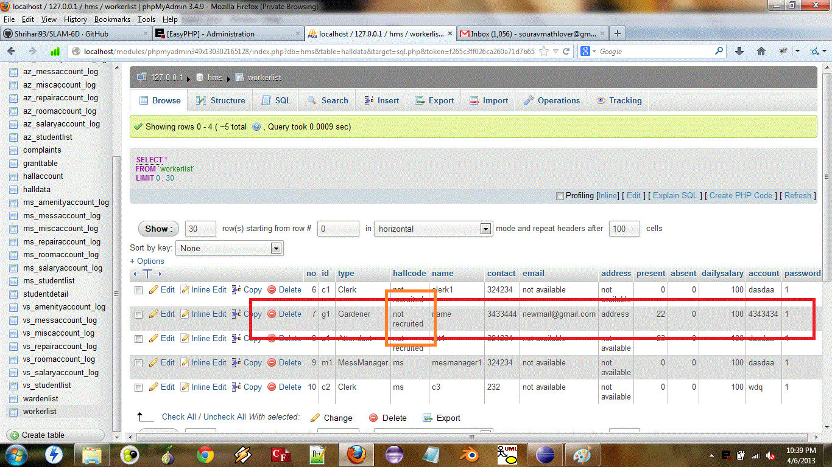

After:-

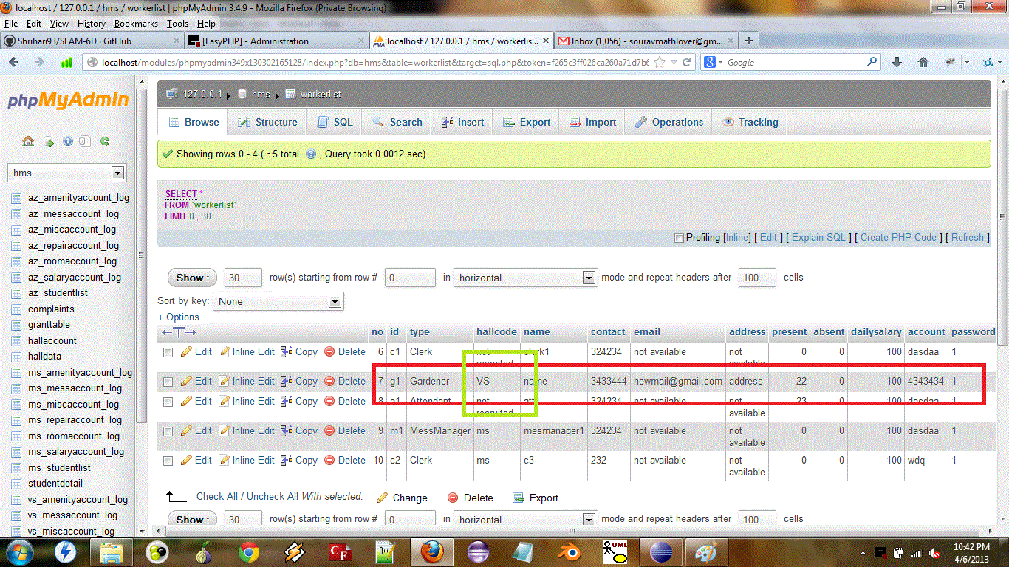

* Mess Manager

Before:-

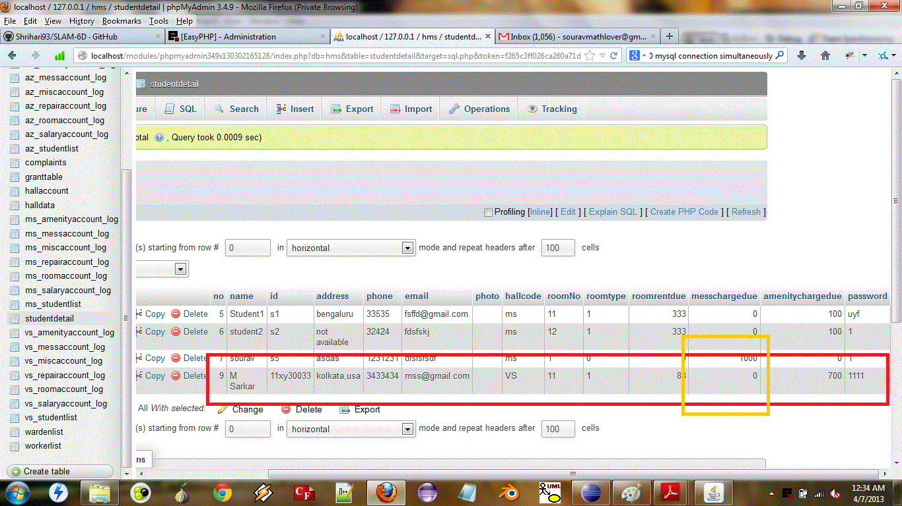

After:-

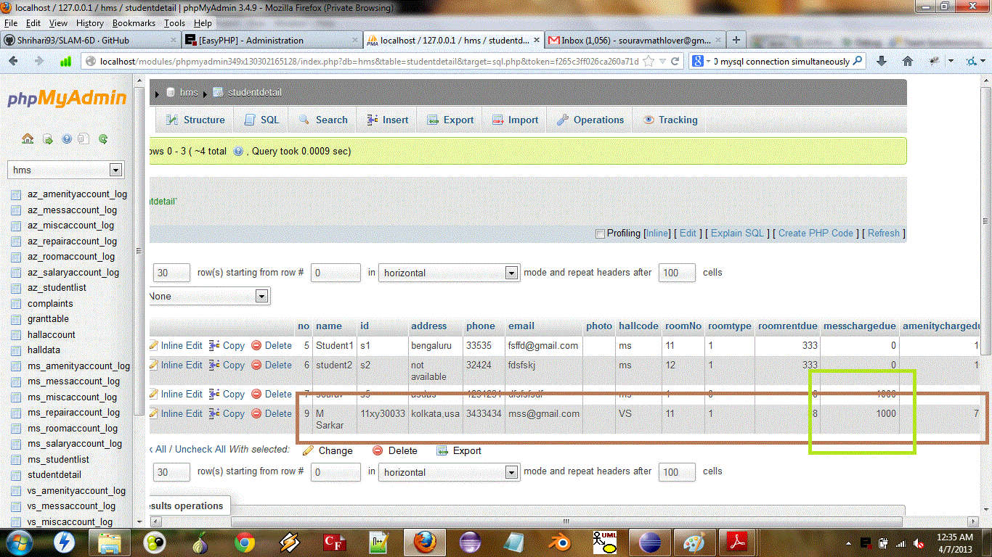

* Modify Hall

Before:-

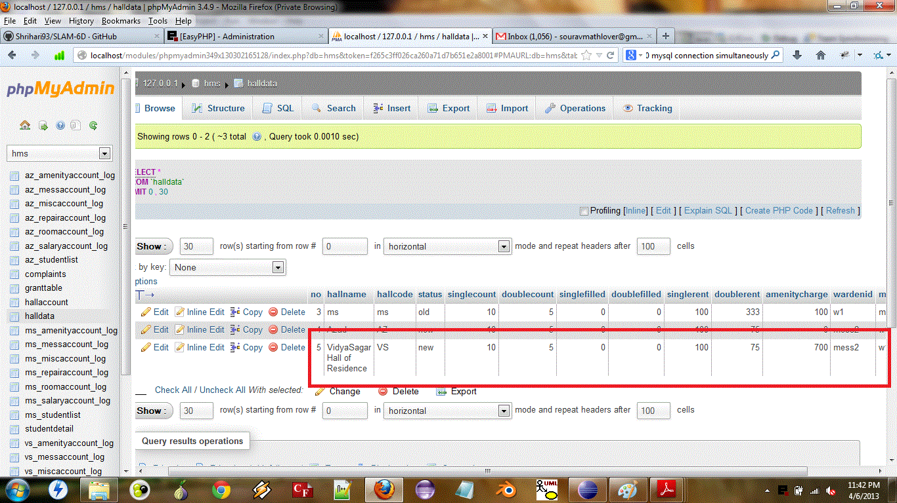

After:-

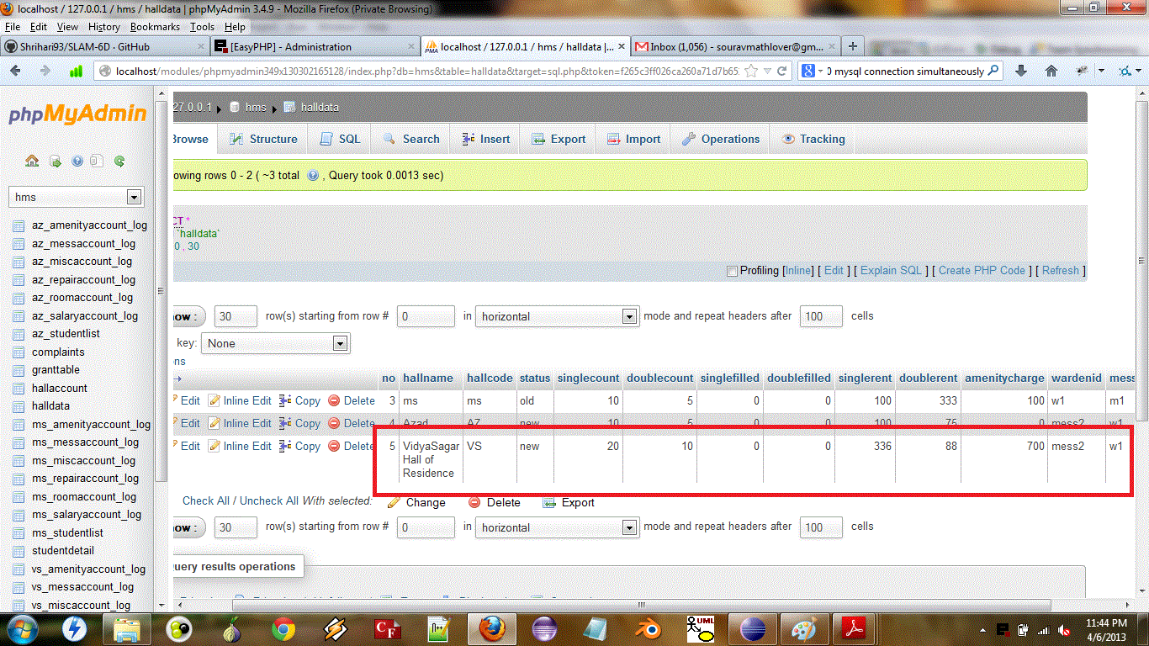

* Request Grant

Before:-

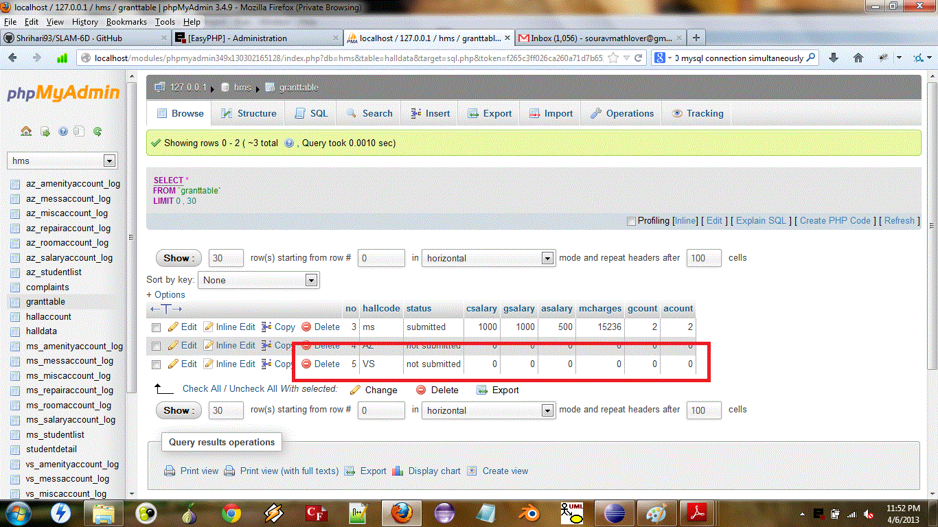

After:-

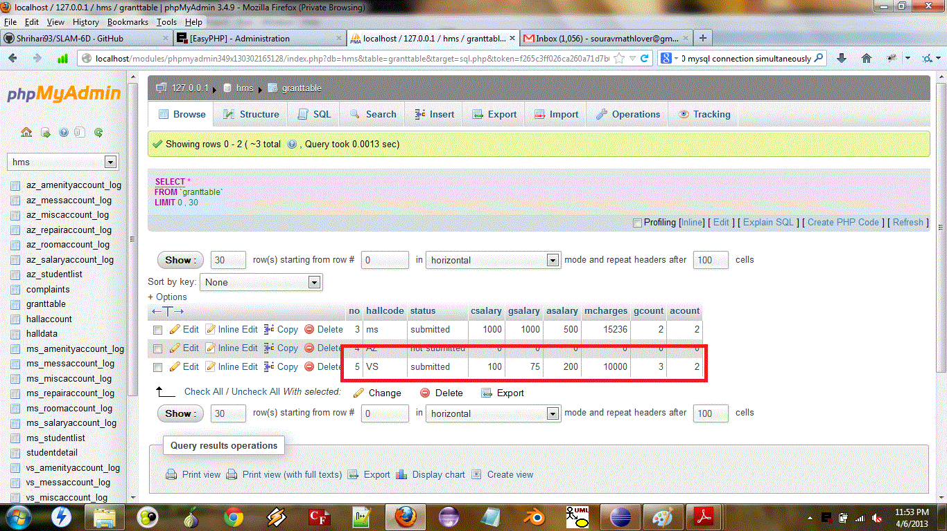

* Retrieve Password

Before:-

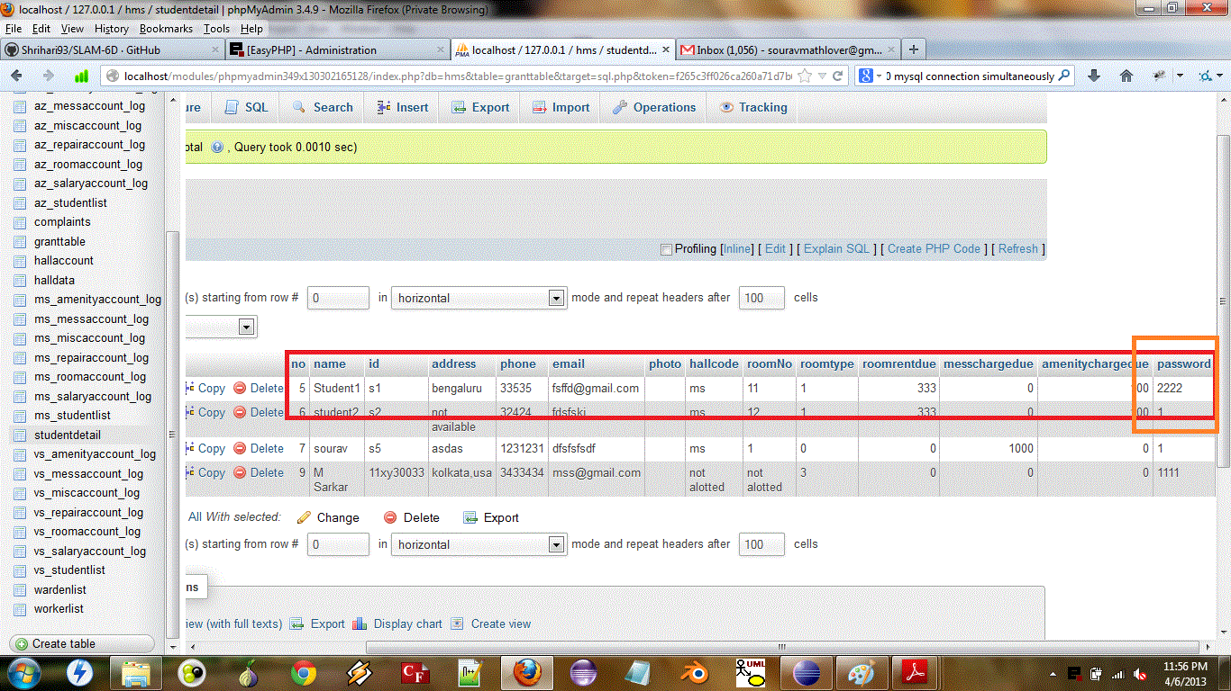

After:-

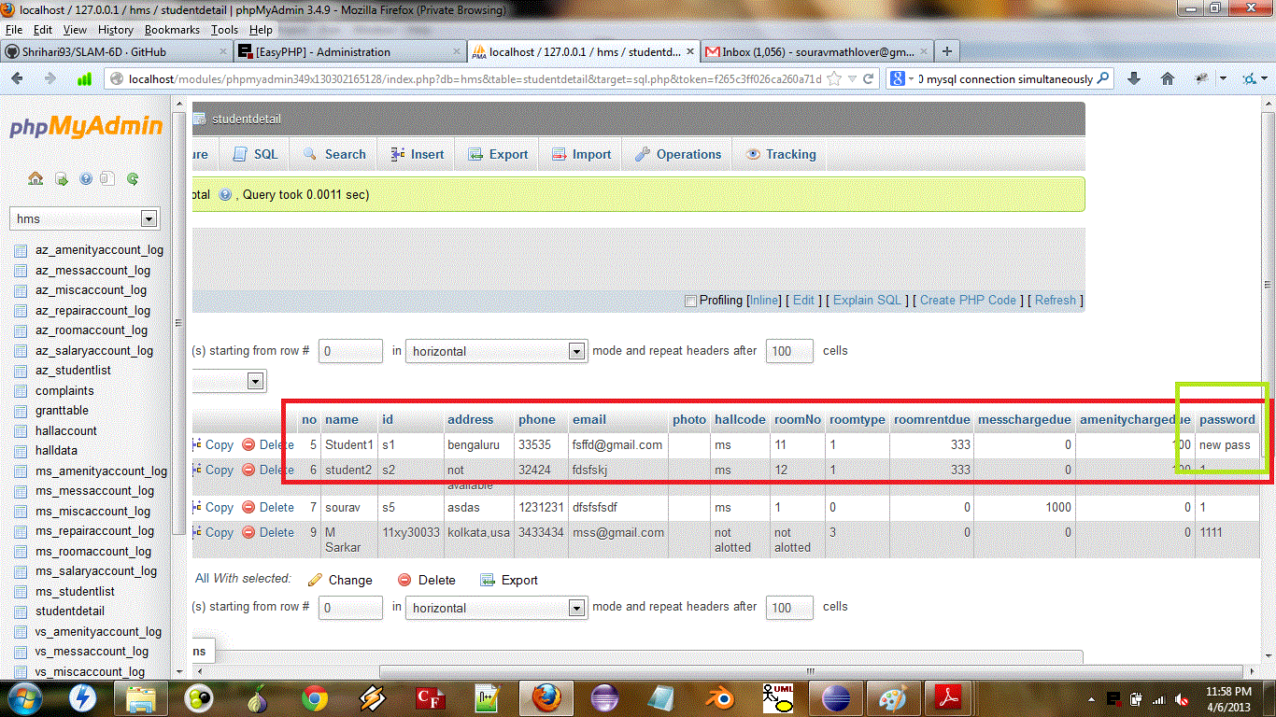

* Room Allot

Before:-

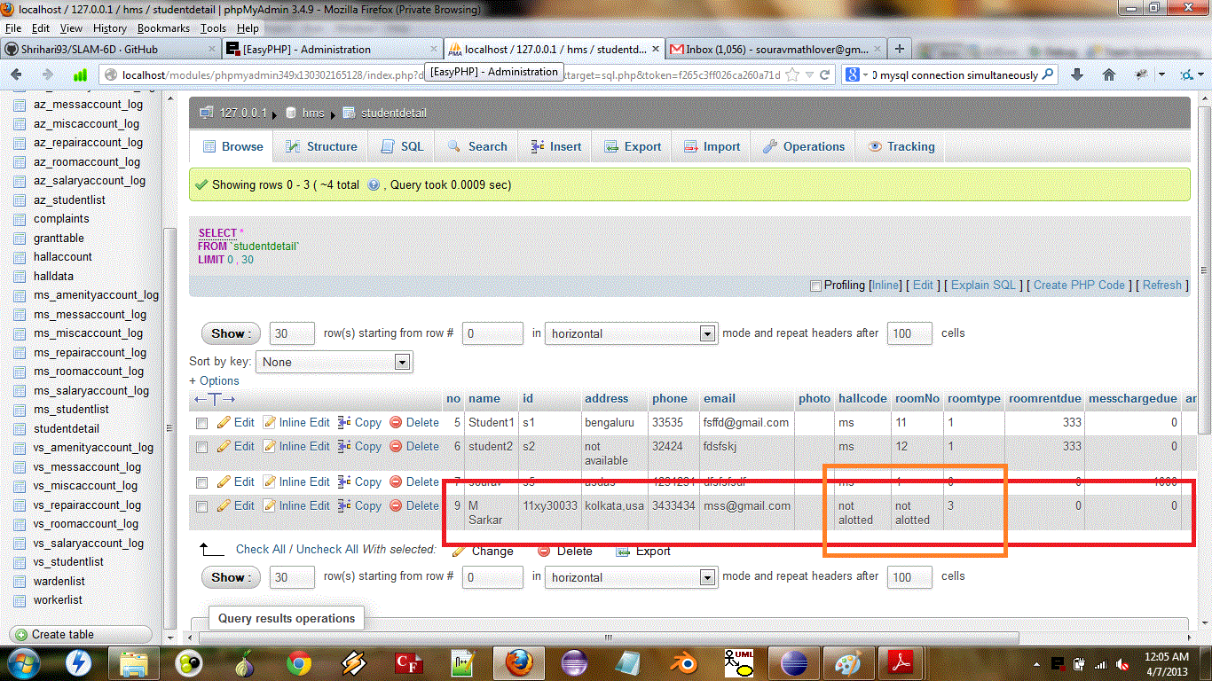

After:-

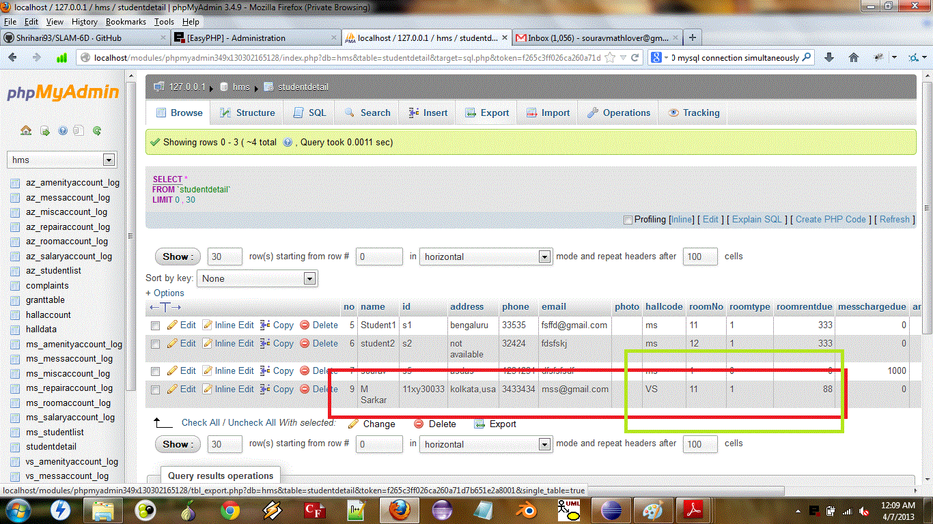

* Room Occupancy

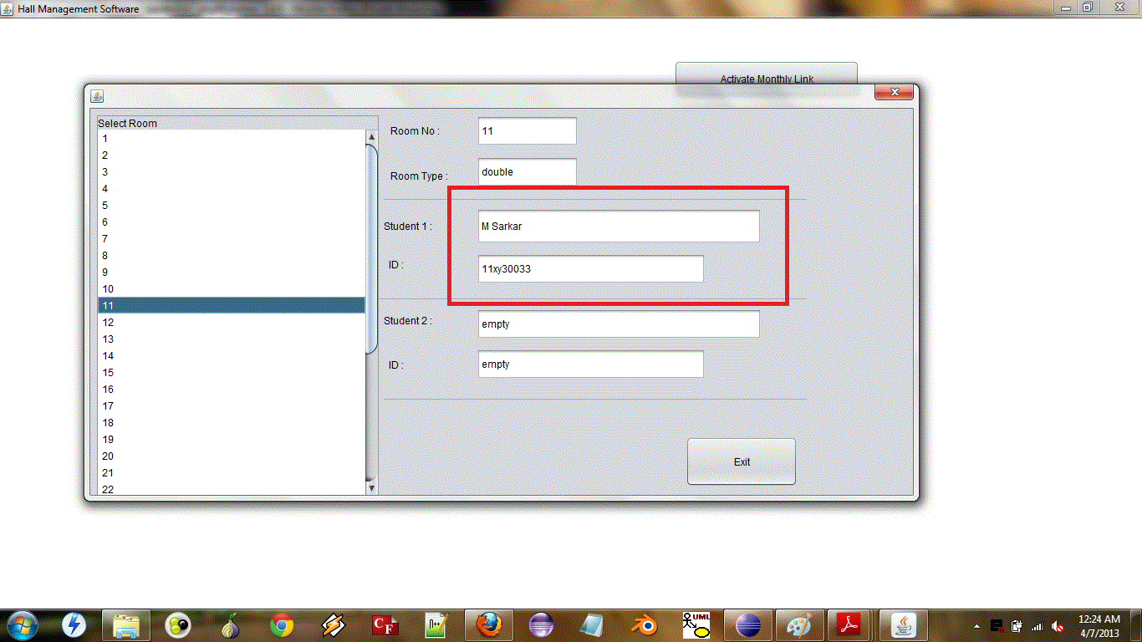

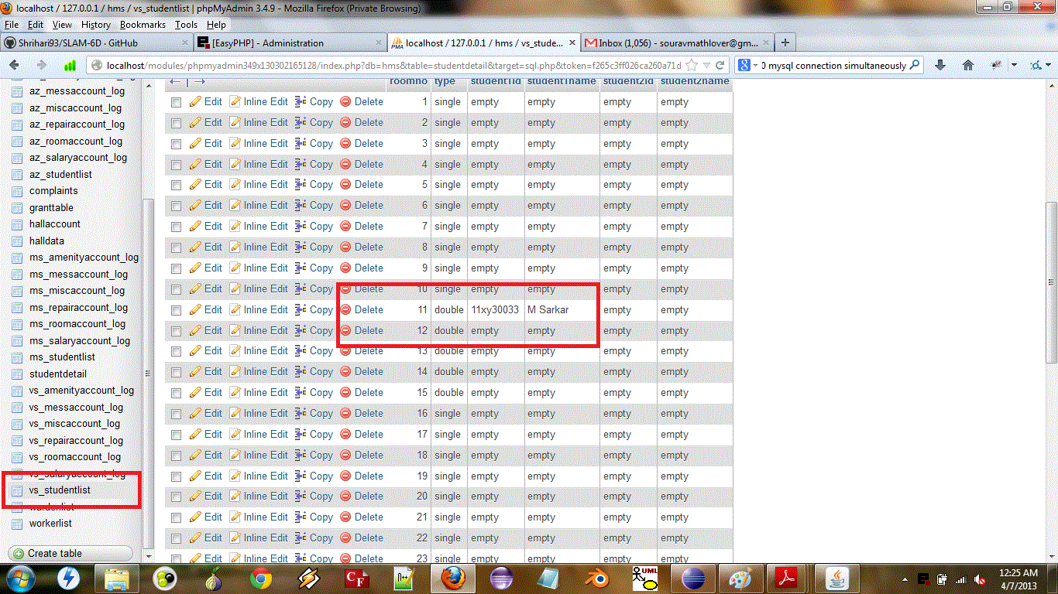

* Student Payment

Before:-

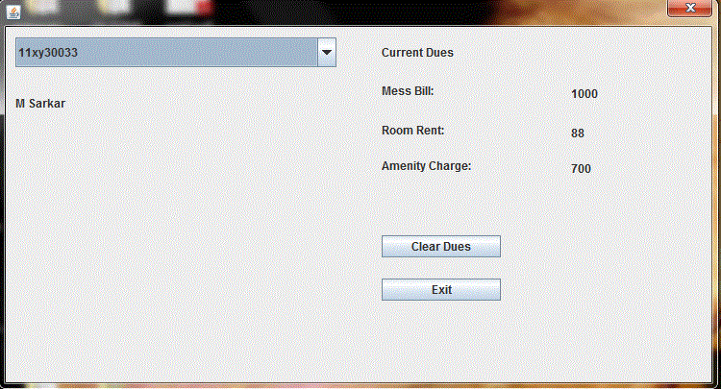

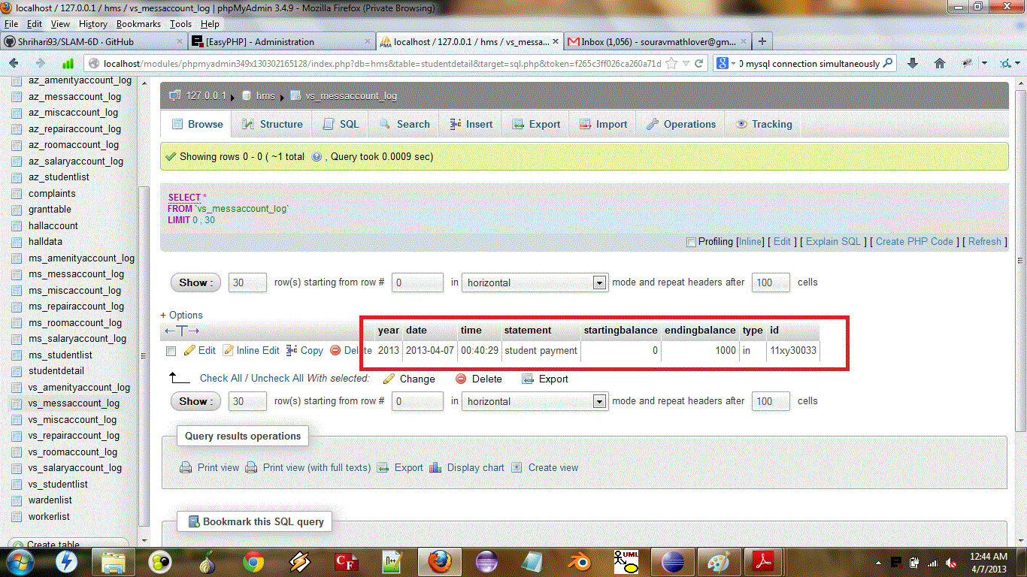

After:-

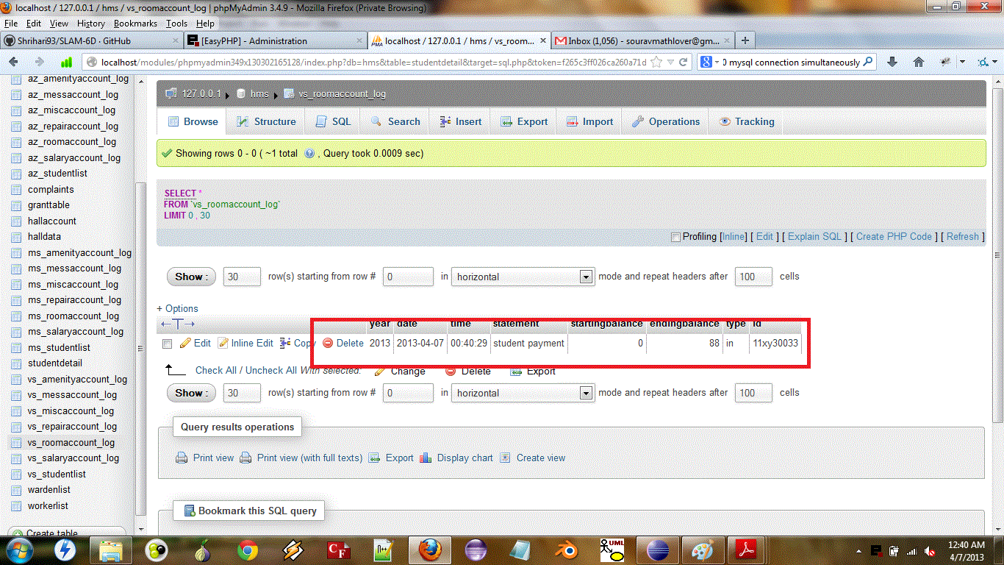

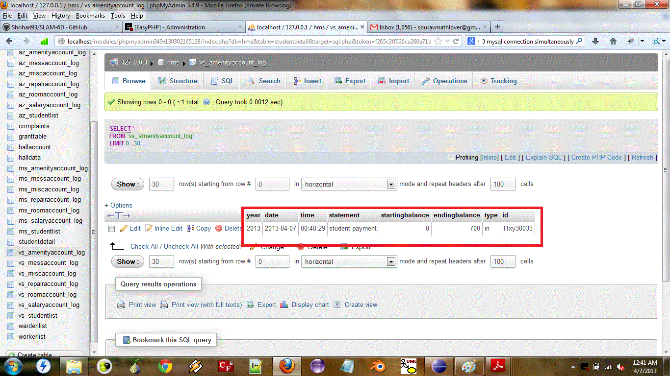

* Setup

Before:-

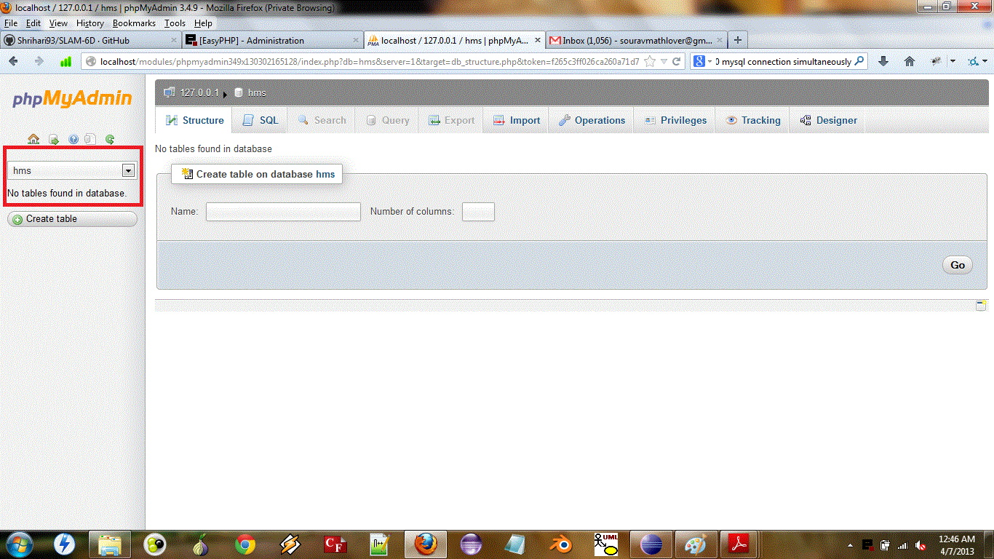

After:-

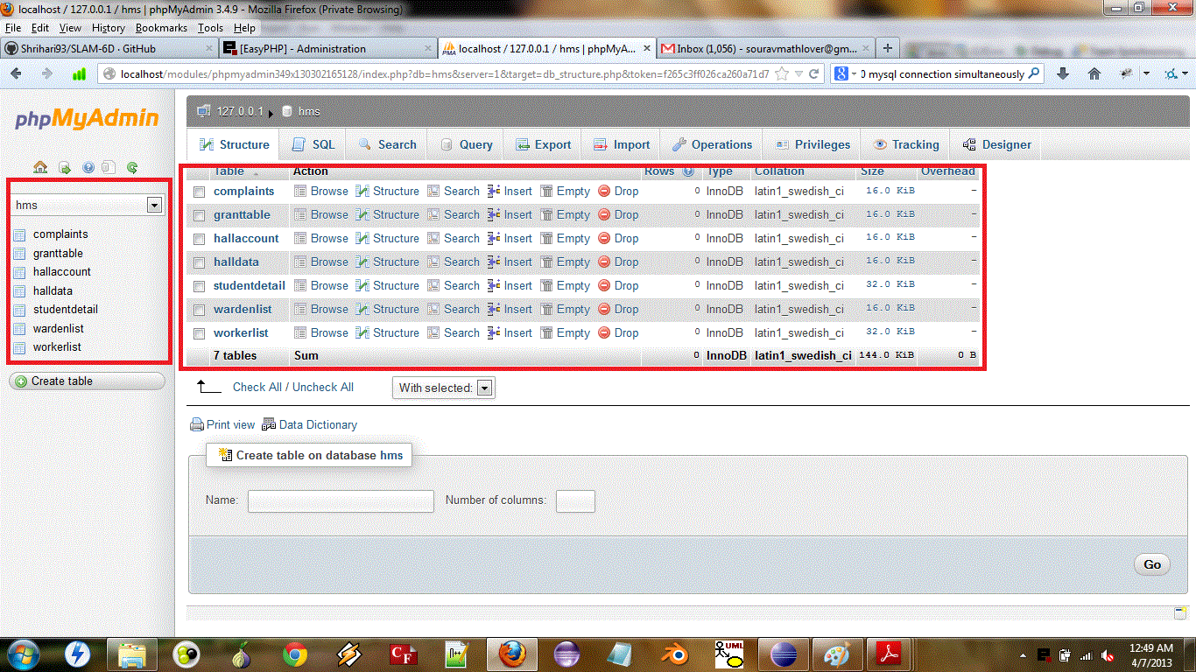

**Integration Testing Results (Black Box):-**

1. Add Warden

(A warden is added to the database)

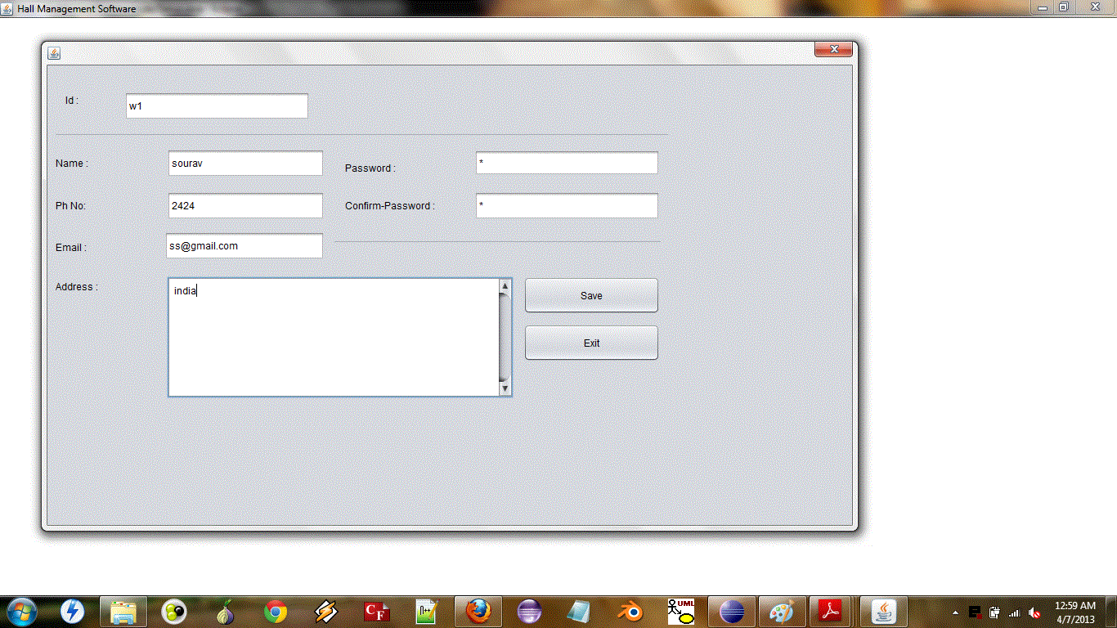

1. Add Mess Manager (A mess manager is added to the database)

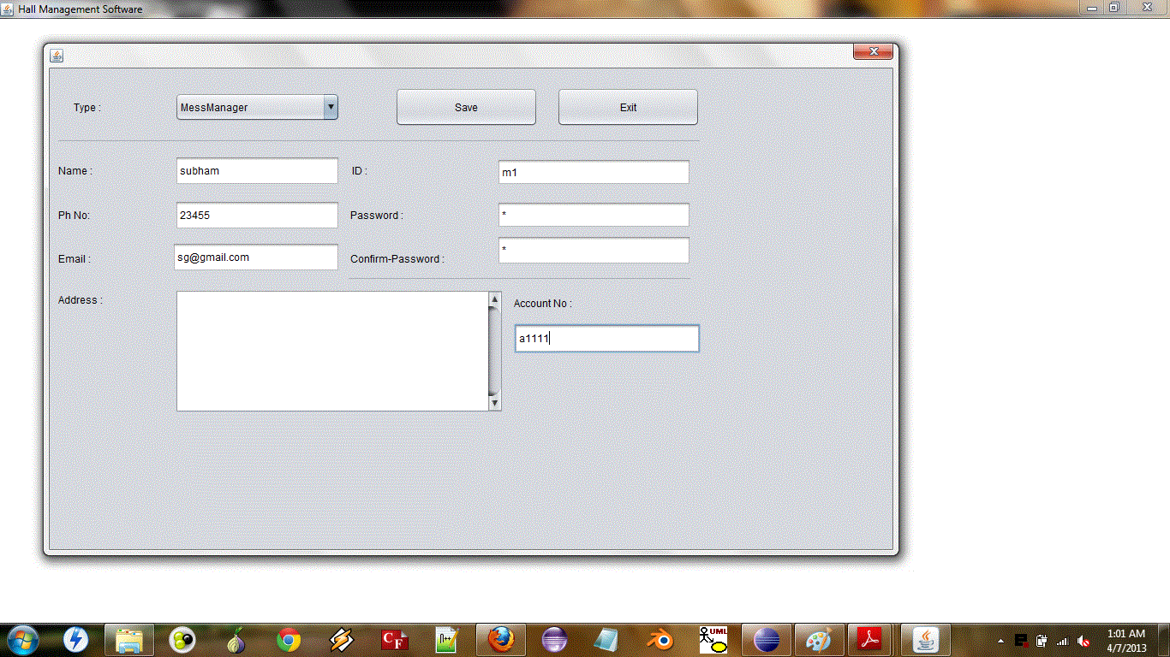

1. Add Hall (A new hall is added to the database with the warden (step 1) and mess manager (step 2) allotted)

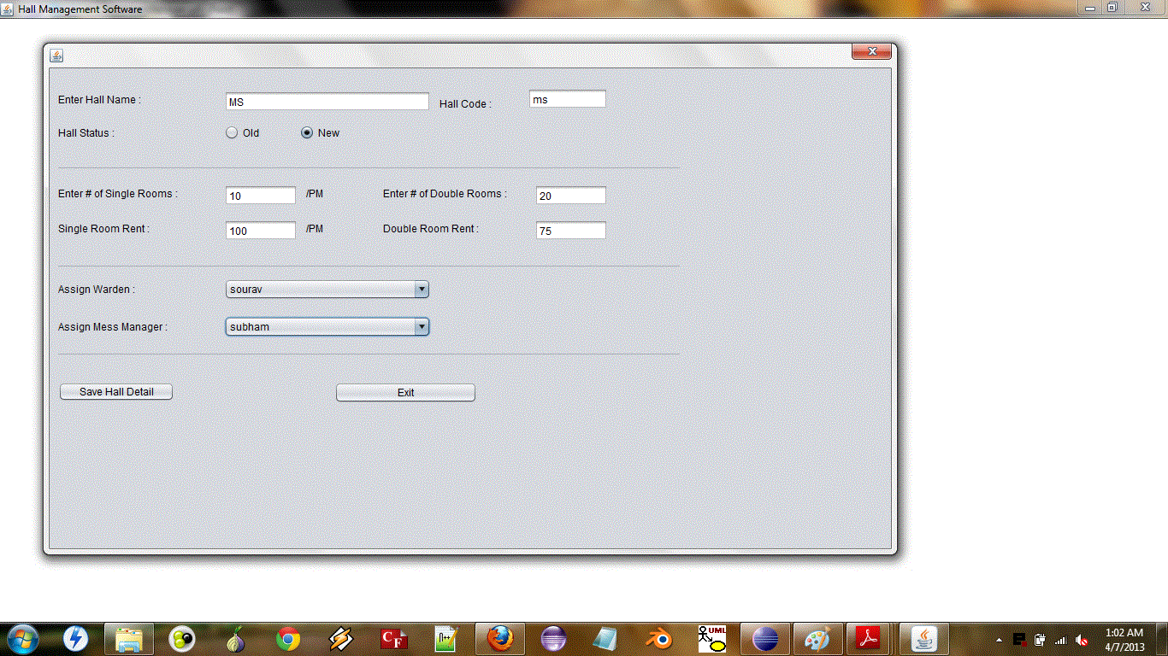

1. Student Admission (A student approaches the HMC for admission)

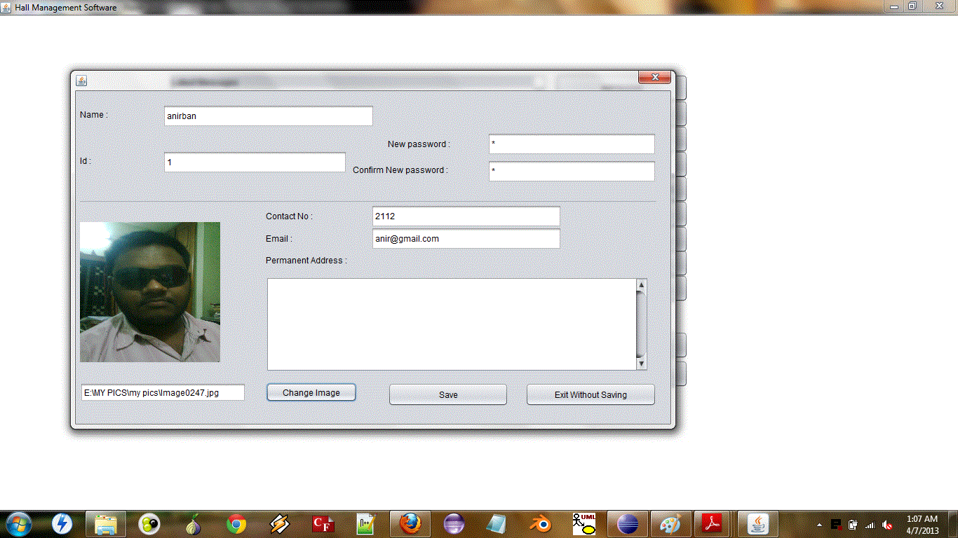

1. Room Allotment ( A room is allotted to the student in the hall according to his preferences)

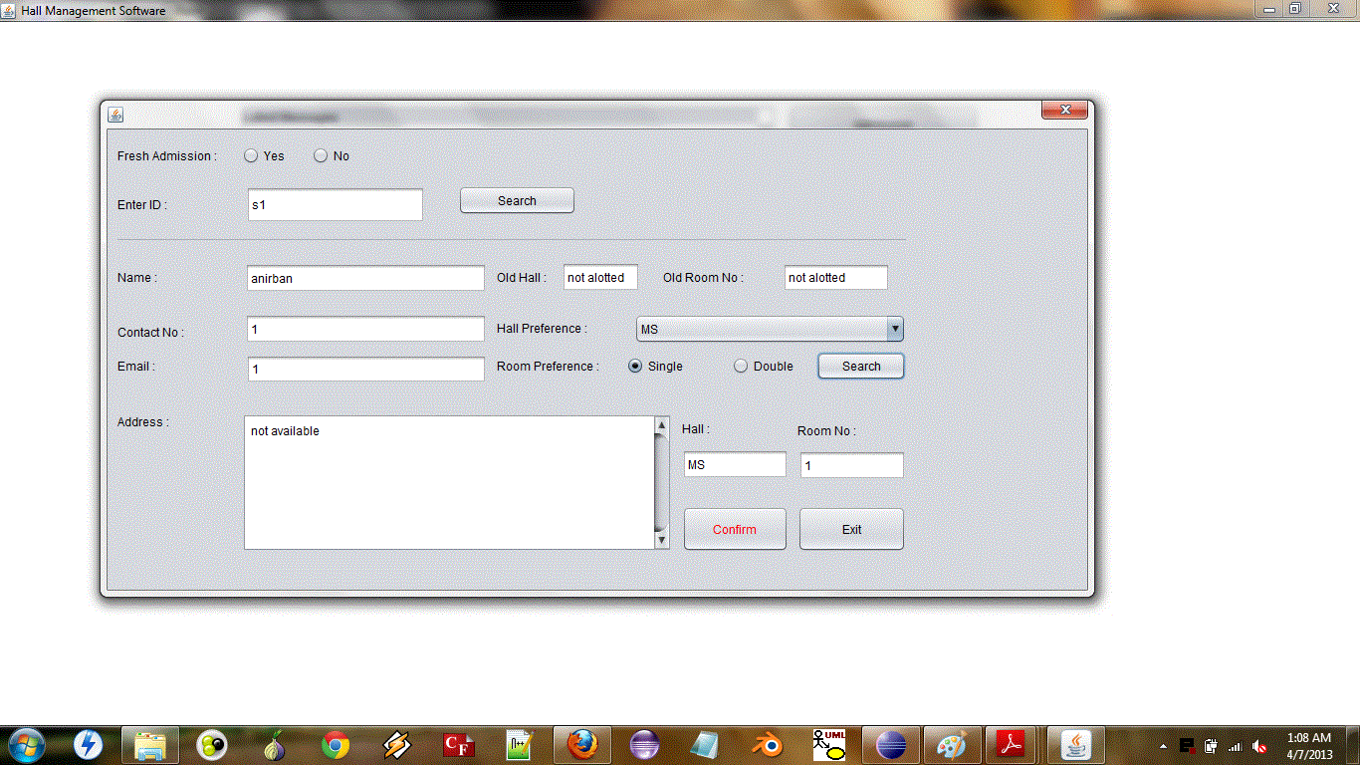

1. Mess Bill Entry (The mess bill for the student is entered by the mess manager)

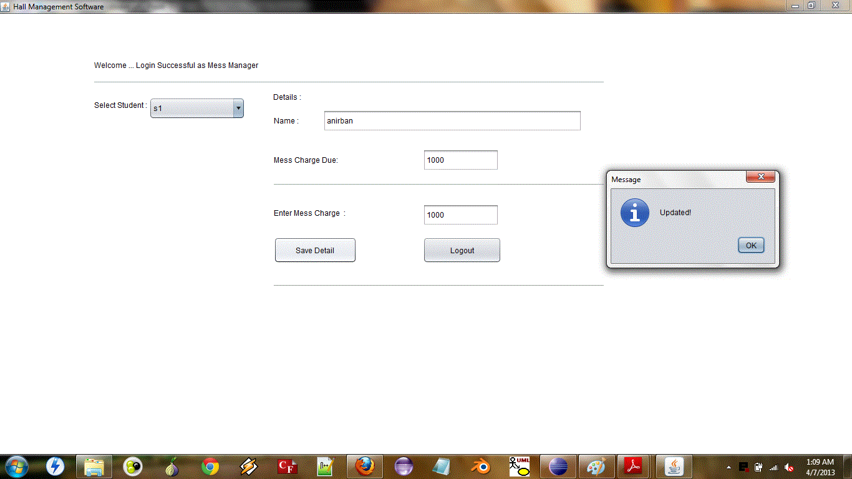

1. Monthly Link Activation (The payment link is activated by the warden)

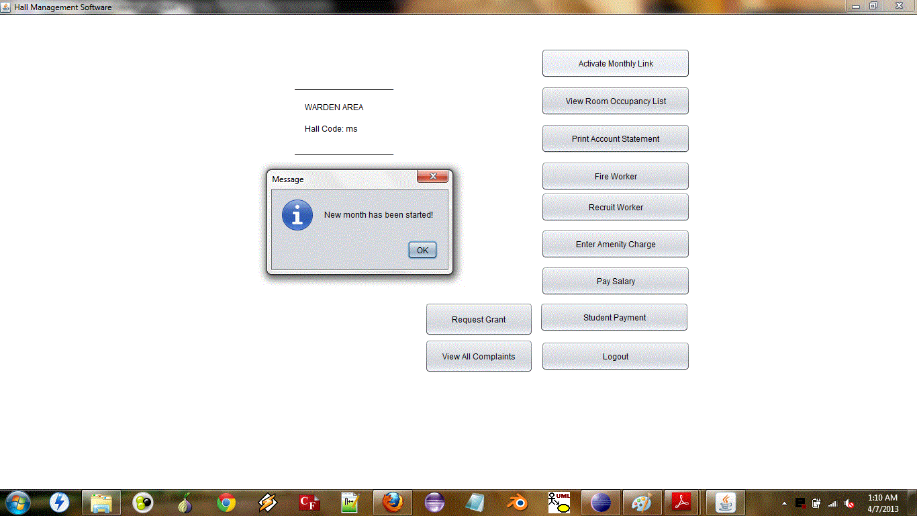

1. Student Due Payment (The student approaches the warden to pay his dues)

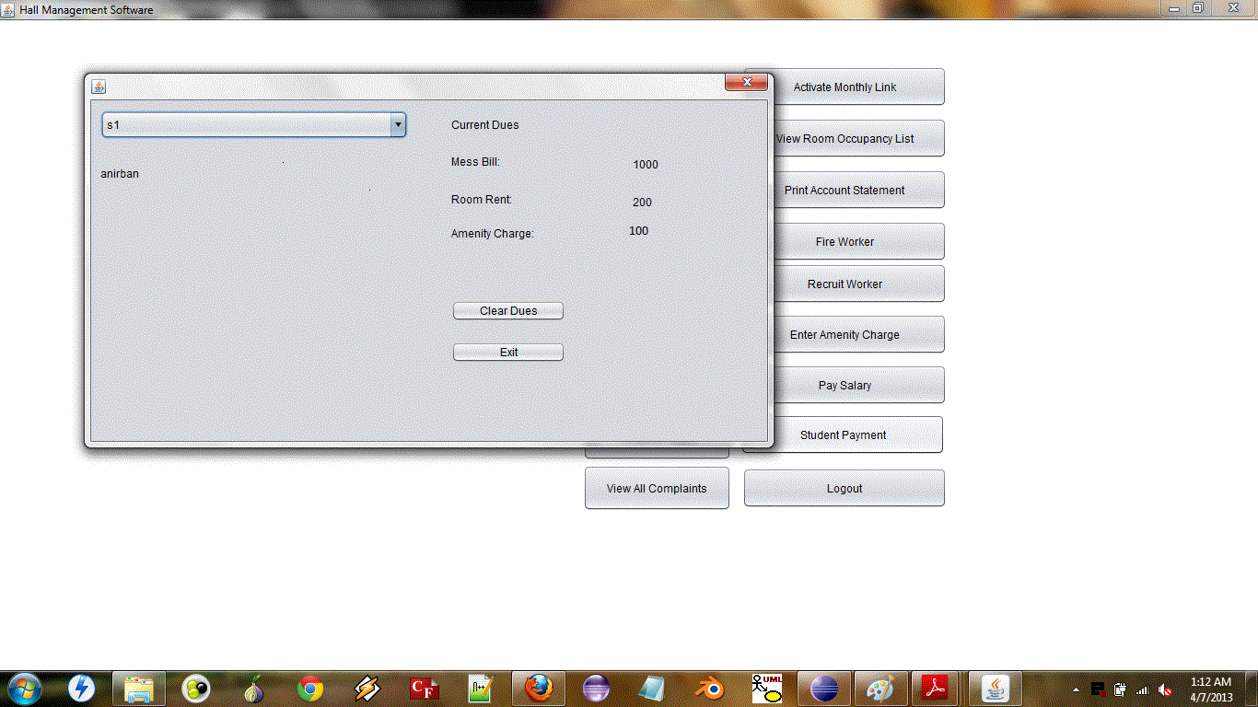

1. Student Dues Cleared (The dues of the student is paid and a receipt is generated)

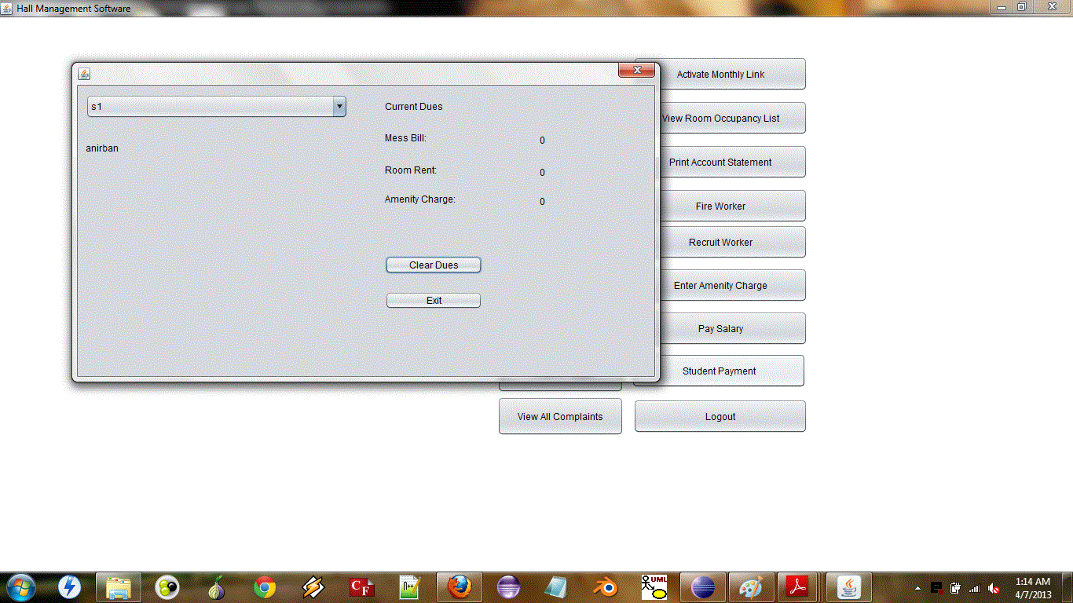

1. Add Complaints (Student logs in to the website and posts his complaint)

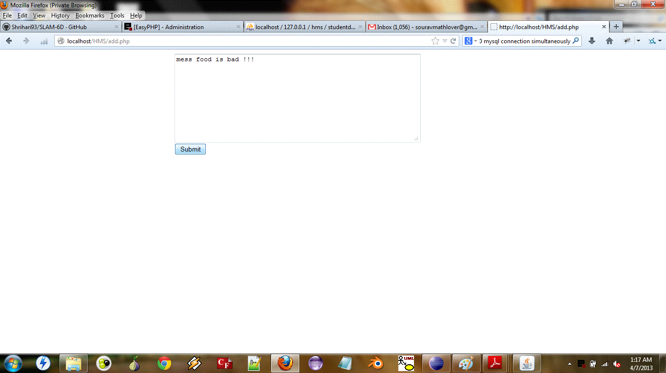

1. Warden Views the Complaint (The warden of the particular hall logs in and views the complaints and can choose to take appropriate action)

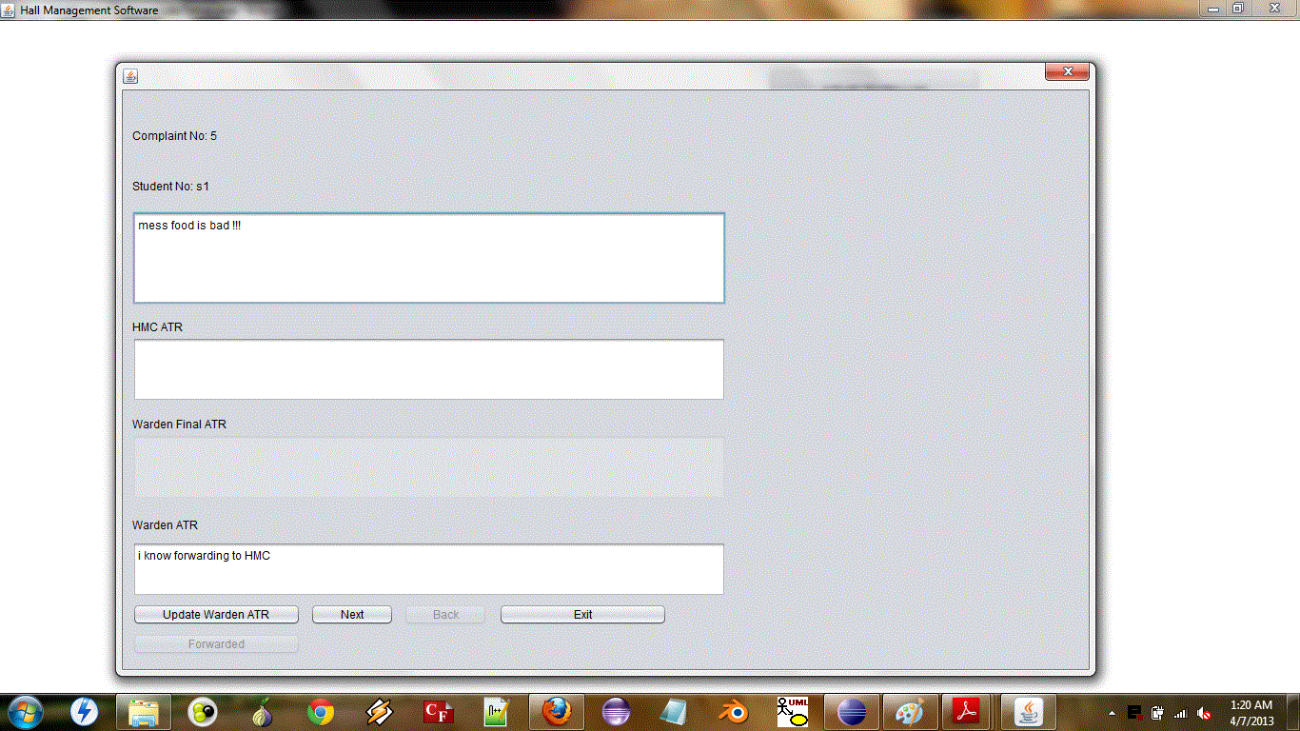

1. Student views the update status of his complaint

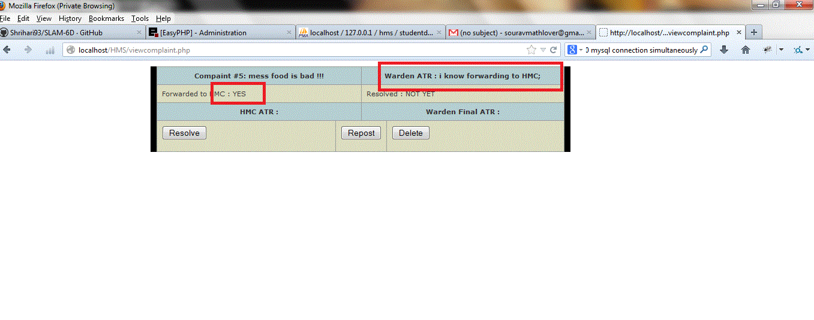

1. HMC gives its report to the complaint

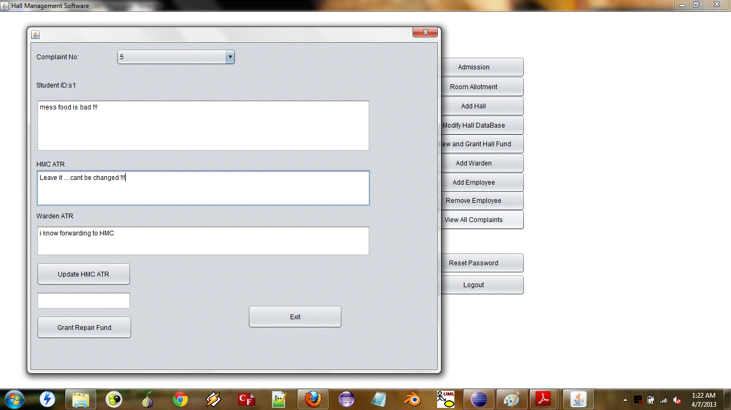

1. Student views the report of the HMC

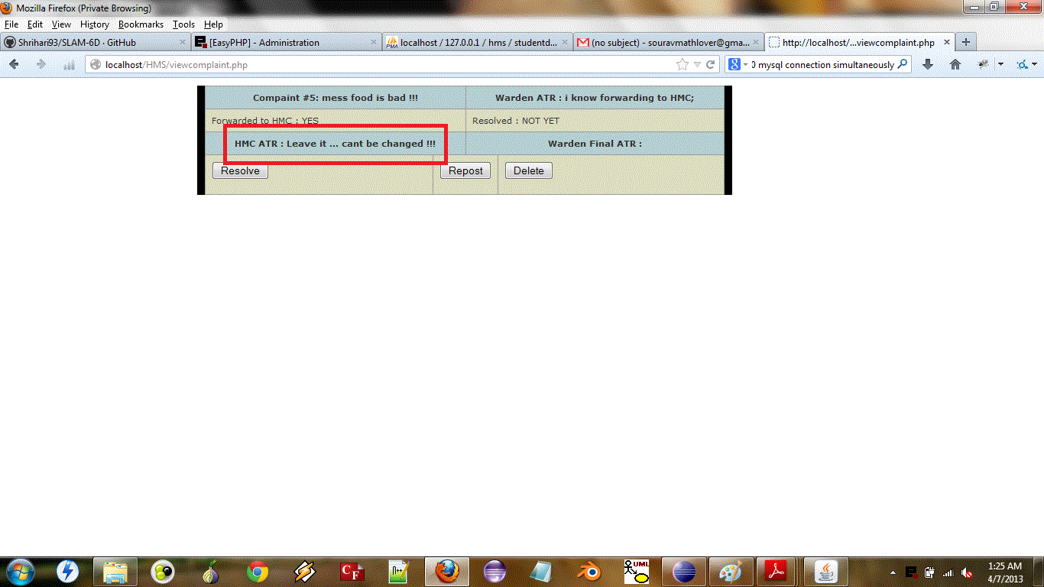

1. Clerk Recruitment (The warden of a hall can employ any worker he wishes from the worker database)

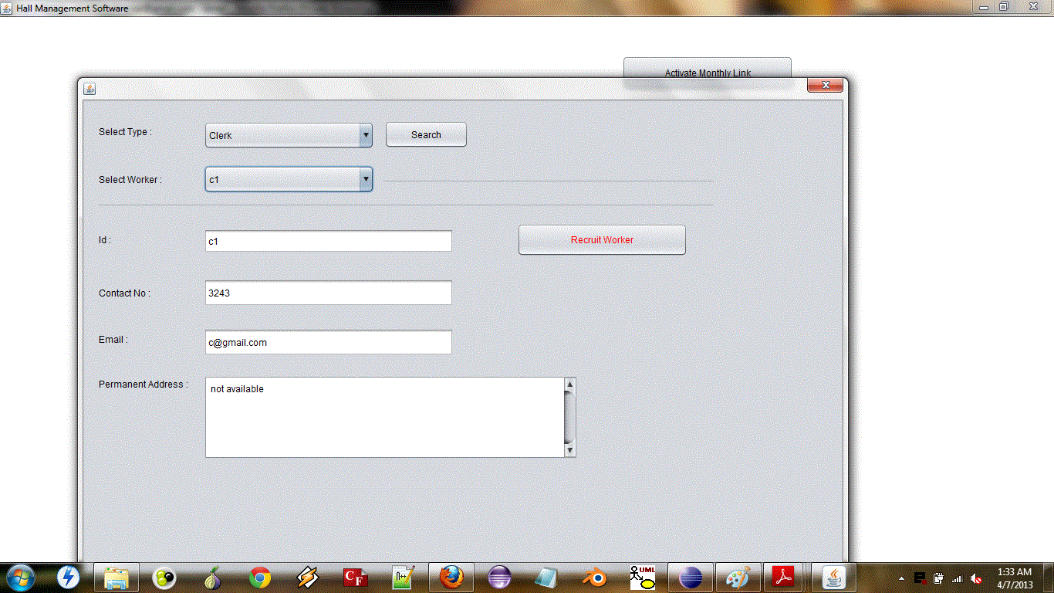

1. Gardener Recruitment (The warden of a hall can employ any worker he wishes from the worker database)

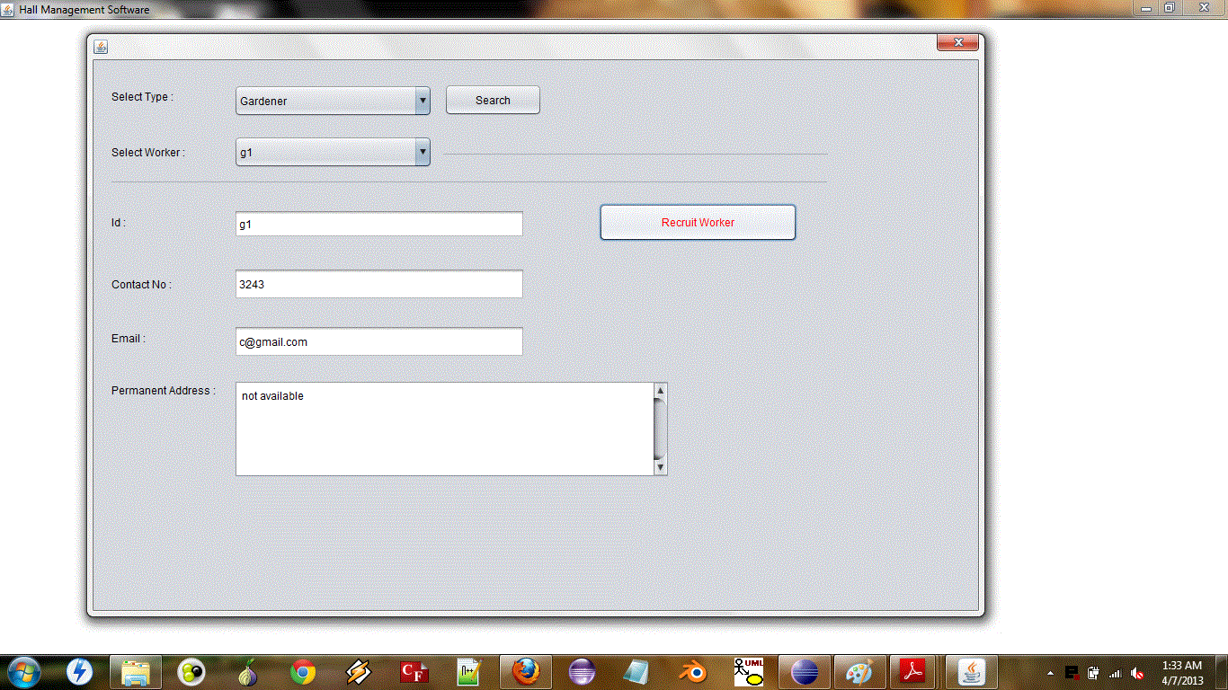

1. Attendance (The clerk can give attendance to the workers of his hall)

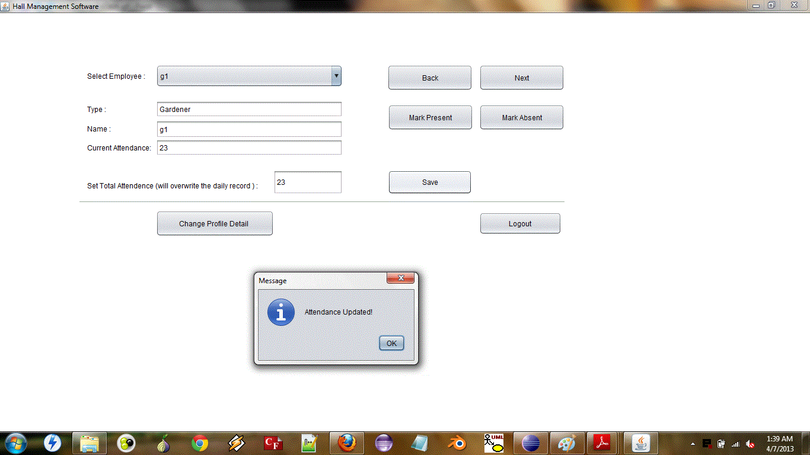

1. Salary payment to the clerk (Warden can pay the salary of his workers and a cheque is generated in his name)

Payment to clerk:-

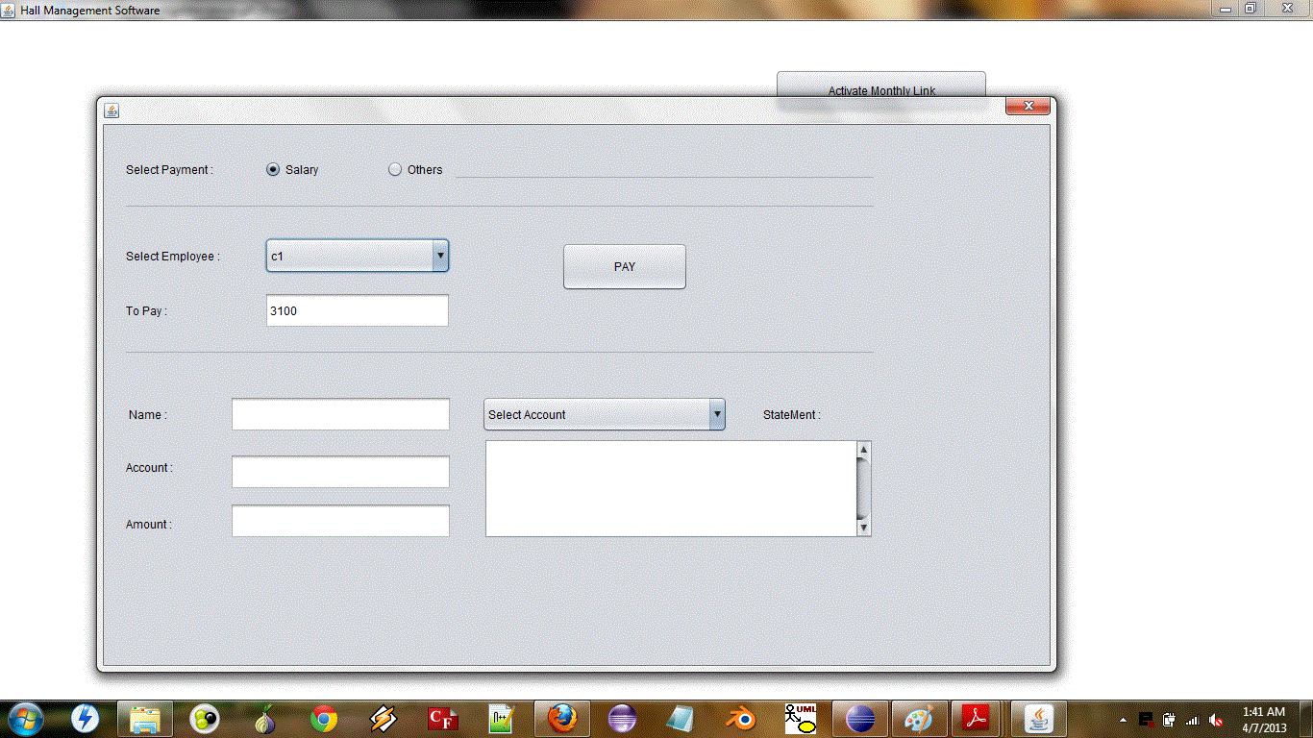

Payment to gardener:-

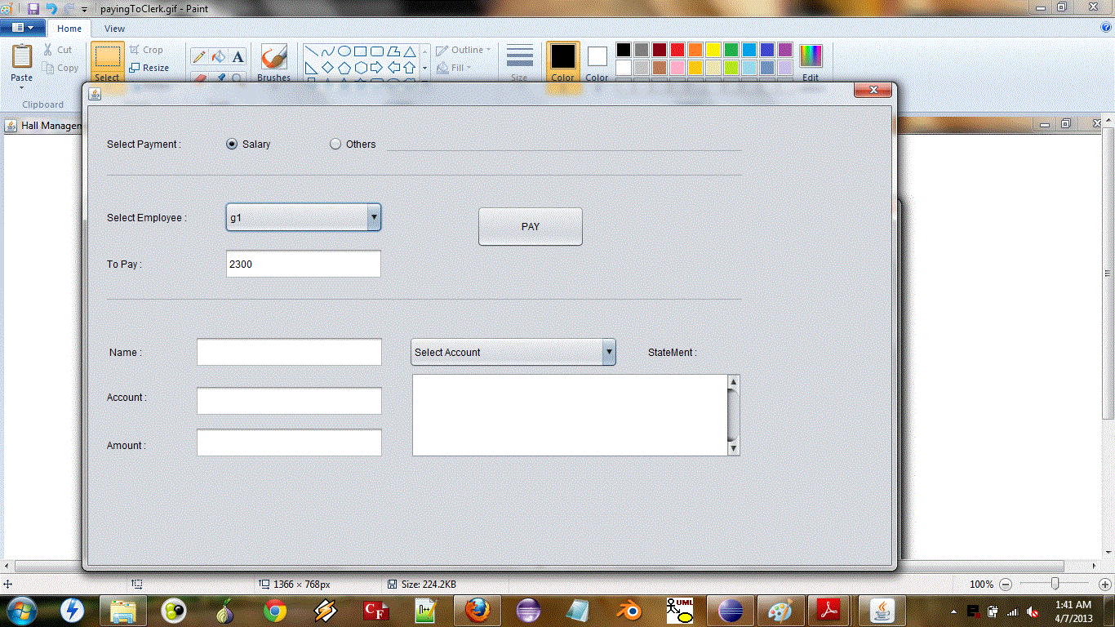

1. Printing account statement (The warden can view account statements of his hall at any time)

